
making the
difference
International
construction market
survey
ICMS
2024
Key highlights
55
markets are warm or hot
32
markets are set to warm up
20
markets are expecting lower
construction cost inflation
2 | International construction market survey 2024
Contents

01 | Introduction

Global construction gets back on stronger footing

Our International construction market survey brings together data, insights and experience across 91 global markets in 42 countries.
Now in its 15th year, it explores how the industry is performing, the challenges it faces and its future outlook.
Our team of global economists collaborated with our local specialists to evaluate input costs – such as labor, materials, and plant – and outlined the average construction costs per square meter for multiple asset classes across several sectors in key markets.
Cost data was collated in Q1 2024 measuring the performance of projects and programs across the previous calendar year. This information provides context and a richer understanding of the balance of supply and demand and the cost pressures within each market.
Since our 2023 publication, we have added three new unique markets in Japan – Fukuoka, Hiroshima and Sapporo. We publish data for 91 markets in total – a list of those markets can be found here.
For simplicity, we have adopted straight-line USD conversion as our primary method of comparison for our cost data. For more information, refer to the methodology section. Detailed explanations of what is included in and excluded from our cost information are given here.
We hope that our report serves as a useful barometer of the general health of the global construction industry, as well as the performance of individual markets and collective regions.


Global Head of Real Estate,
Neil Bullen, introduces our
research. Our latest report
sees global construction
emerging from a period of
significant economic
challenge and slowly
returning to strength as
inflationary pressures ease,
build costs stabilise and
confidence rises.
The global real estate market is emerging from a challenging period of inflationary pressures, volatility and disruption. The construction sector has proved resilient with steady activity overall.
Neil Bullen, Global Head of Real Estate
02 | Global economic outlook

Shock absorber: global economy to march steadily through a pivotal political year
While momentum continues across in-demand industries, structural economic challenges remain deeply rooted across the globe, placing a drag on growth.

Taken as a whole, the global economy is stable and improving, though it is a long way from booming. Several indicators point to a period of sluggish growth to come.
Despite this, there are reasons to be positive. The risk of a global recession has been skirted, with inflation easing, and commodity and energy prices softening. As a consequence, there is increased expectancy in global financial markets for cuts in interest rates to stimulate growth.
However, this growth will be hard won – and slow to materialize.

High stakes in an election year
A sequence of overlapping risks is being held in the balance by policymakers.
2024 is set to see the greatest number of elections in global history, with swathes of the world’s population heading to the ballot boxes.
Recent geopolitical instability, rising tensions and potential moves towards more isolationist, de-globalizing policies to win votes may affect the global economic picture.
This illustrates a complex and unpredictable economic outlook, which many commentators expect to remain subdued for the rest of this decade.
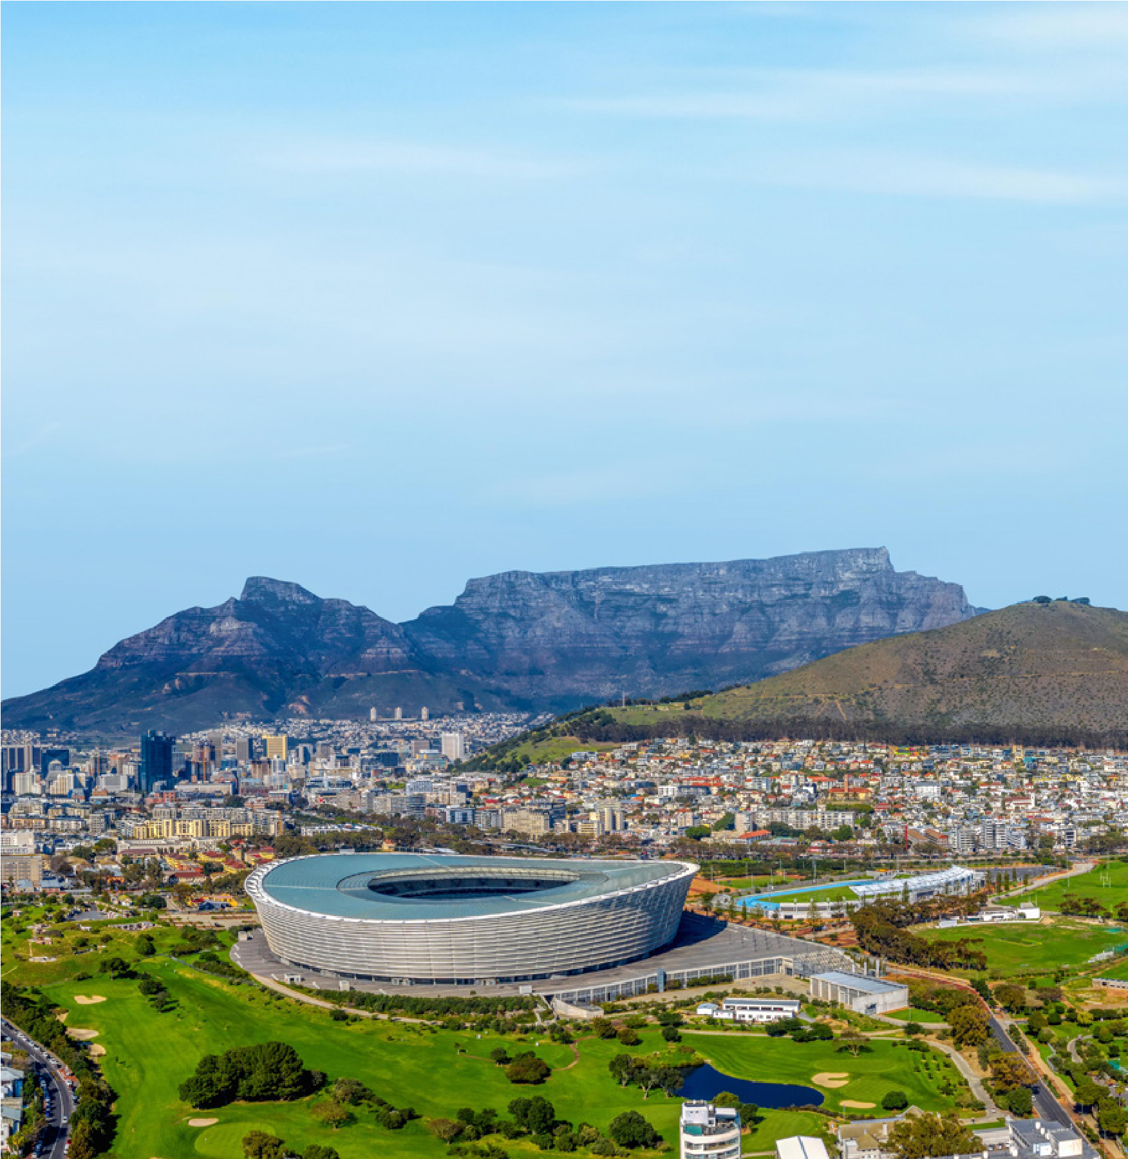
However, as the past 12 months have demonstrated, expectations may well be exceeded, with the world economy showing remarkable resilience through continued shocks.

Global forecasts paint a mixed picture
Overall gross domestic product (GDP) has held up better than anticipated, growing by 3.5 percent in 2022 and 3.2 percent in 2023, an out performance compared with the IMF’s forecast of 2.7 percent for 2023.
While high interest rates were expected to dramatically pinch household budgets and constrain spending in developed markets, savings accumulated during the pandemic have so far provided a buffer to stave off recessionary pressures in many markets.
However, tight monetary policies to counter inflation, the removal of fiscal support and low productivity in several major economies could put the brakes on growth in the short and medium term. Increased propensity to use tariffs and subsidies to safeguard domestic interests could continue as many hit the election campaign trail, further fragmenting global trade and exacerbating geopolitical tensions which arise as a result.
Forecasts for several of the G20’s emerging economies have been revised down and will weigh on the global economy.
India, spurred on by one of the world’s youngest populations, is now expected to deliver 6.8 percent GDP growth in 2024 – the highest in the G20, but a percentage point lower than in 2023.
China’s ambitious growth agenda is being hampered by a downturn in its real estate sector, on which the national economy is heavily reliant, and the forecast is for growth to slow from 5.2 percent in 2023 to 4.6 percent in 2024.
There is general consensus in the forecasts published by both the IMF and the Organization for Economic Co-operation and Development (OECD). The emerging economies of India, Indonesia, China, Turkey and Russia are all expected to be the strongest performers, continuing the trend of the past two decades.
The weakest emerging economies are expected to be Argentina, where we could see radical policies to stem its inflationary spiral and economic decline, and South Africa, where citizens have headed to the polls for the most important election in 30 years. South Africa’s economic outlook is being undermined by high unemployment, continued electricity shortages and high public debt levels.
Turning to the developed economies, Germany is expected to show the weakest performance among the eurozone, as elevated energy costs, decreased foreign investment and record high interest rates take their toll. However, some indicators now point to the business outlook steadily improving.
Spain is forecast to outperform other EU nations with 1.9 percent growth forecasted. Its economy has been bolstered by the return to pre-pandemic levels of tourism and waves of financial investment in recent years from the EU Recovery Fund.
Figure 1:

2024 Real GDP forecast of G20 economies
Region
%
(
)

-2.8

0.2

0.5

0.7

0.7

0.9

0.9

1.2

1.5

1.9

2.2

2.3

2.4

2.6

2.7

3.1

3.2

4.6

5.0

6.8

0.8

3.2
-4.0
-2.0
0.0
2.0
4.0
6.0
8.0
Argentina
Germany
United Kingdom
Italy
France
Euro area
Japan
South Africa
Canada
Australia
Spain
Brazil
Republic of Korea
Mexico
Saudi Arabia
United States
Republic of Türkiye
Russian Federation
World
People's Republic
of China
Indonesia
India

Inflation rates offering respite
While still above target levels, headline inflation has been falling from the peaks in 2022. Globally, the rate sat at 6.8 percent in 2023, and is on track to fall to 5.9 percent in 2024 and further to 4.5 percent in 2025, according to IMF data.
Freight costs have seen a dramatic decrease of 75 percent since January 2022, but are still 79 percent above their pre-pandemic levels.
The overall easing of inflation is being aided by shipping and commodity prices continuing to settle following the disruption of the pandemic. As a result of softened demand and supply chain bottlenecks easing, prices of key metals have dropped over the past year. The World Bank has reported reductions of 14.5 percent in the cost of iron ore, 25.1 percent for nickel and 17.1 percent for zinc, with these expected to fall further through 2024.
Greater certainty around energy supplies and the impact of tight monetary policy on global demand have also been pushing costs downwards. The average price of oil has fallen by 28.5 percent since its peak in June 2022 as production in the US and Iran has swelled.
In Europe, where reliance on Russian oil and gas caused prices to soar in 2022 with the outbreak of the war in Ukraine, markets have shifted to imports from the US and northern Africa, allowing the region to shore up reserves and stabilize prices.
Figure 2:

World Bank Commodity Price Index
Index: 2016=100
Aluminium
Iron ore, cfr spot
Copper
Lead
Tin
Nickel
Zinc
50.0
100.0
150.0
200.0
250.0
300.0
350.0
400.0
Jan 2020 Figure 3:  Oil, natural gas and coal prices | Nov 2020 | Sep 2021 | Jul 2022 | May 2023 | Mar 2024
Crude oil, Brent Crude oil, Dubai Crude oil, WTI
0.0
Index: (2016 = 100)
Coal, Australian
Coal, South African
100.0
200.0
300.0
400.0
500.0
600.0
700.0
Index: (2016 = 100)
Natural gas, US
Natural gas, Europe
Liquefied natural gas, Japan
0.0
200.0
400.0
600.0
800.0
1000.0
1200.0
1400.0
1600.0
1800.0
Mar 2024 Jan 2020 Nov 2020 Sep 2021 Jul 2022 May 2023 Mar 2024 Jan 2020 Nov 2020 Sep 2021 Jul 2022 May 2023 Mar 2024
Index: (2016 = 100)
Jan 2020
Nov 2020
Sep 2021
Jul 2022
May 2023
0.0
50.0
100.0
150.0
200.0
250.0
300.0
With inflation continuing to ease this year, there will be increased calls for central banks to start cutting interest rates. However, a sense of caution is to be expected as monetary policymakers and governments walk a careful line between encouraging growth and keeping a handle on inflation. As a result, we may not see rate cuts in some major markets until the tail end of 2024 or early 2025.
As US rates remain high for longer, this will cause acute challenges for emerging markets with large dollar denominated debts and could make it more difficult for other central banks to lower their own rates. That said, the expectation is for rates to start to ease from mid-2024 into 2025 as banks work to spur on fresh investment.
The interest rate outlook for emerging economies is not as dovish as it is for developed countries. In both Brazil and Mexico, rates are expected to be close to 10 percent at the end of 2024, and in India, only a moderate fall is expected from the 6.5 percent peak to 5.75 percent. The need to control inflation is still the main policy objective.
Figure 4:
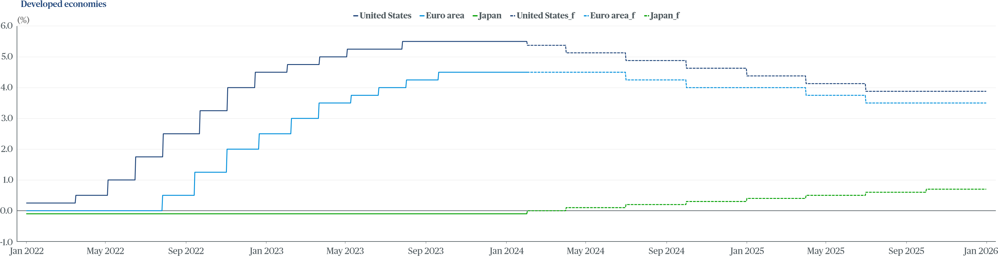
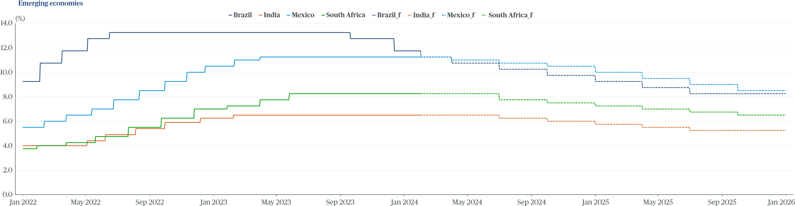
Developed and emerging economies interest rate and forecast

Hurdles remain for price deflation
Geopolitical tensions, particularly the possibility of an escalation of the conflict in the Middle East, could spell further trouble for inflation and interest rate forecasts.
The cost of mechanical and electrical components in Europe, for example, has picked up due to the redirection of shipping routes by Far East suppliers, which dominate production of electronics, around the Cape of Good Hope to avoid the Red Sea. At the start of the Red Sea crisis, there was an upside risk to inflation from renewed goods delays and higher shipping costs. However, so far, we have not seen this materialize.
Shortages of skilled labor are providing another barrier to unpicking stubborn inflation. Unemployment rates in the G7 economies are at historical lows, in part as a result of early retirement decisions and career moves triggered during the pandemic. While low unemployment rates should support demand and protect economies from risks of outright recessions, it is also pushing wage costs upwards, adding to persistent inflationary pressures.
Figure 5:
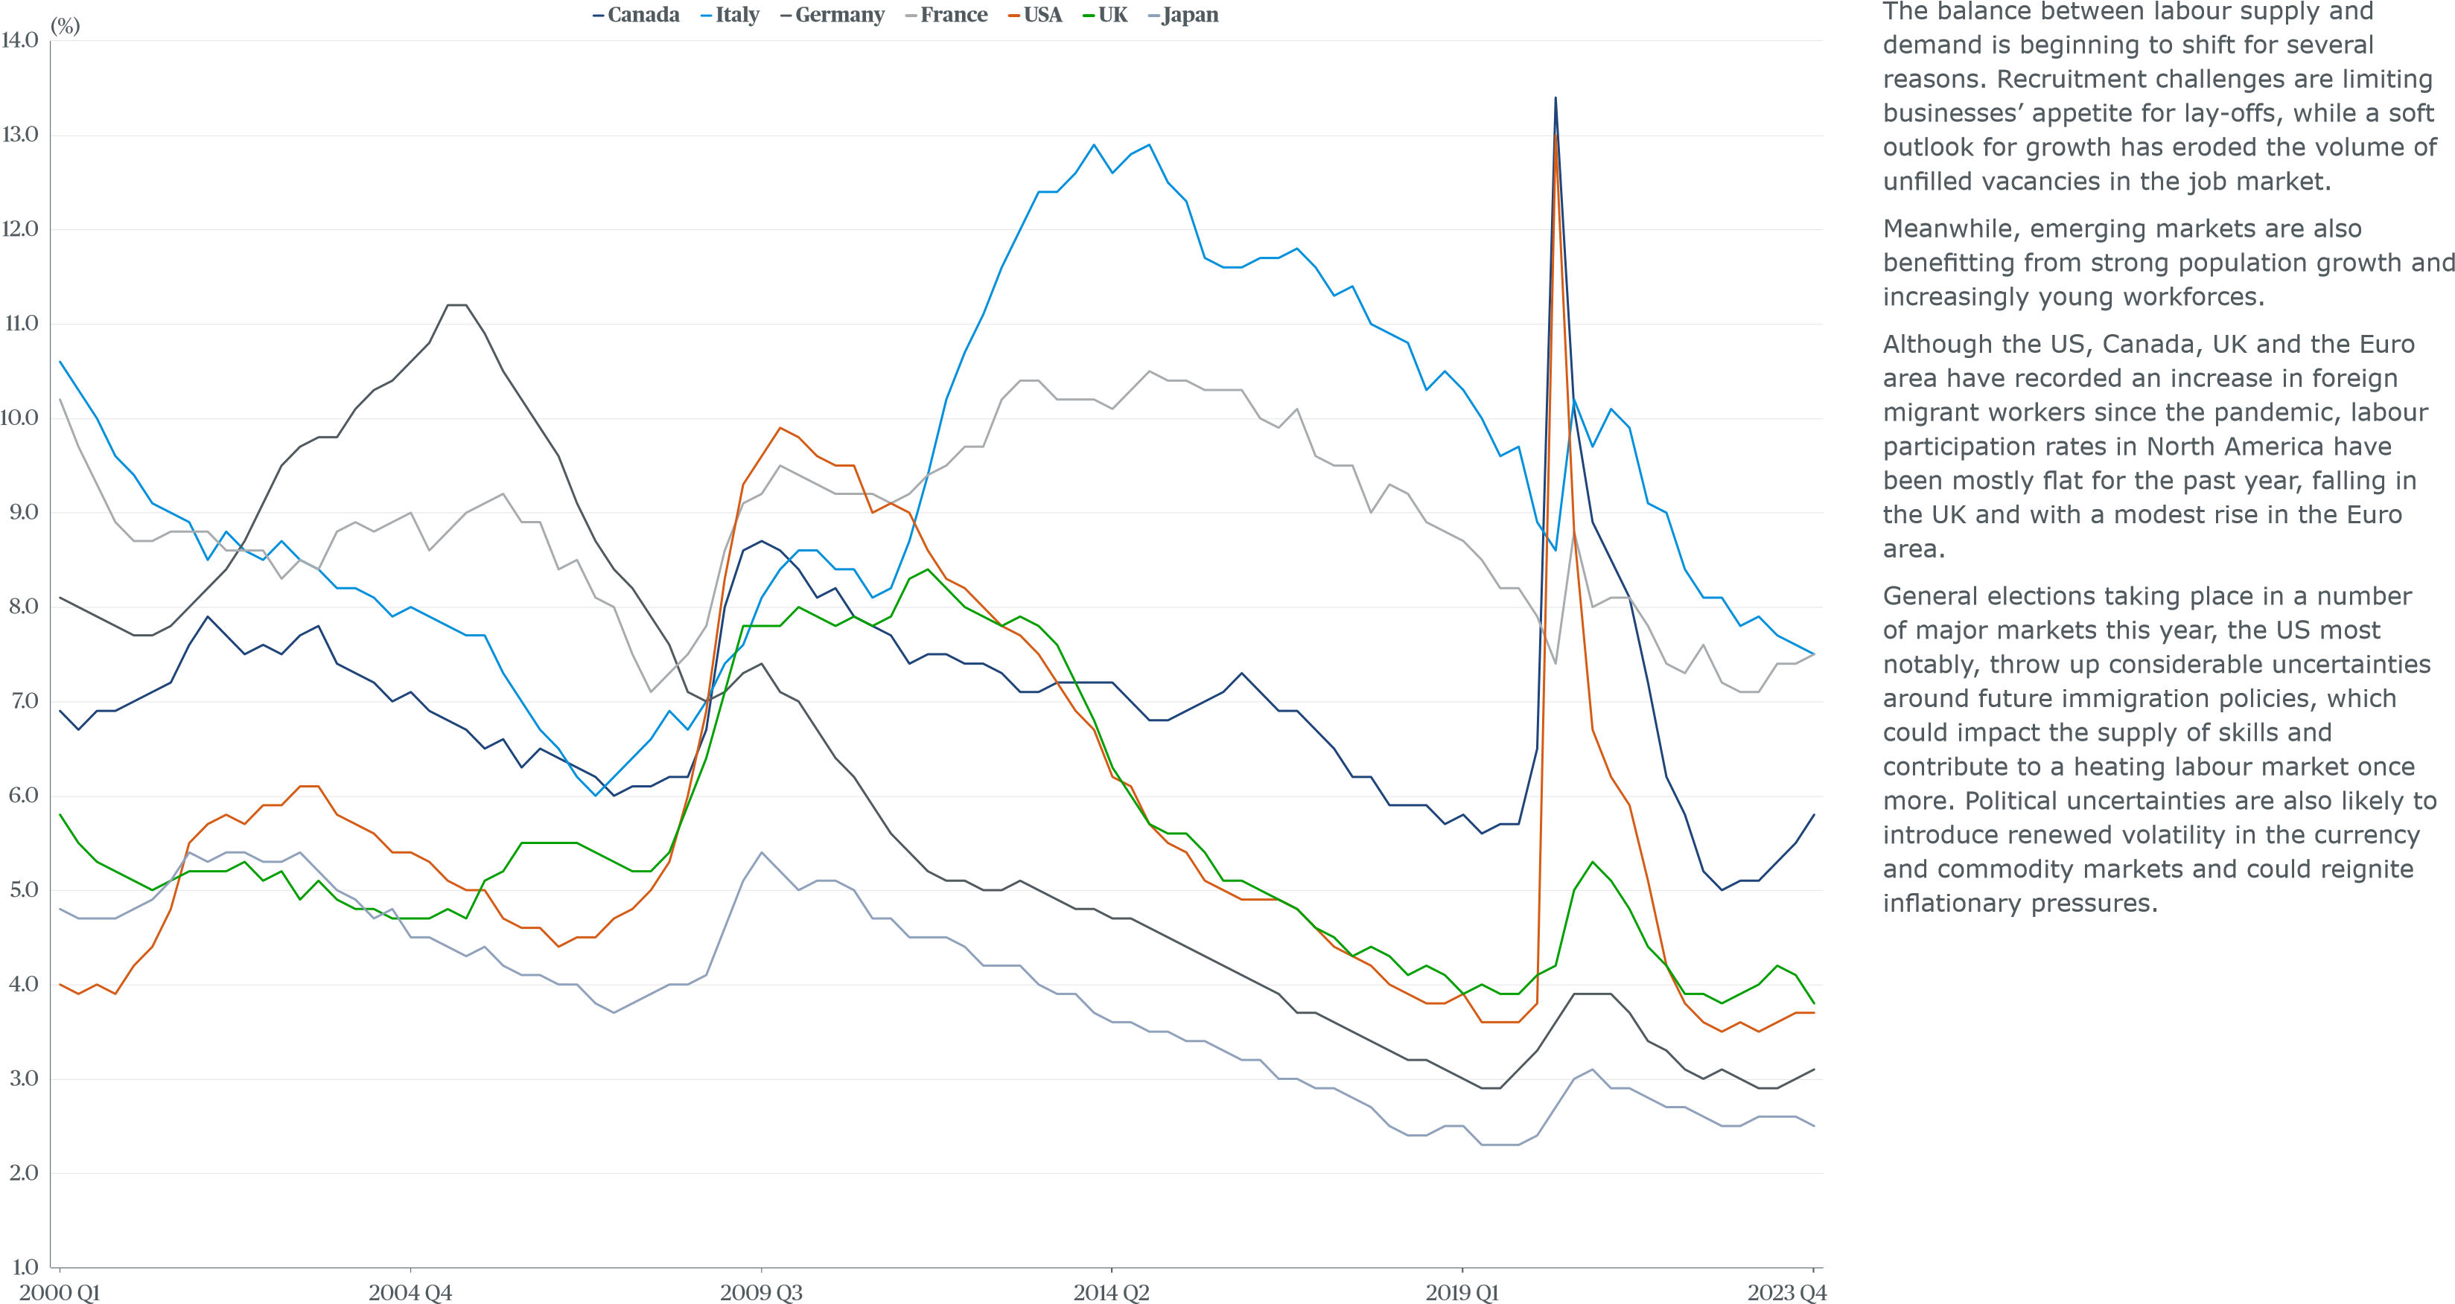
Unemployment rates in G7 economies

New catalysts for investment
There are green shoots of recovery appearing across global regions, particularly in the revival of industrial manufacturing, which is proving an important catalyst for investment and productivity.
In the US, subsidies through the Inflation Reduction Act are supporting the advancement of green technologies, particularly battery manufacturing – working to challenge China’s current dominance in this area. Similarly, the Biden administration’s Chips and Science Act is spurring on the development of the country’s domestic manufacturing sector.
Advanced manufacturing continues to boom across its traditional heartlands in Asia. Europe is also accelerating its investment with the EU’s Net Zero Industry Act.
Artificial Intelligence (AI) holds the potential to raise worker productivity and incomes, contributing to growth over the medium term.
AI could help break out of the post-2008 cycle of diminishing returns from technological progress and slow adoption of new digital technologies into production processes. But this comes at the potential cost of job displacement and increased inequality – making AI both an opportunity and challenge in equal measure.

Climate change to define long-term growth prospects
Climate change will be the defining long-term challenge facing the global economy. According to the World Economic Forum, the global economy could lose ten percent of its total economic value by 2050 as a result of climate change.
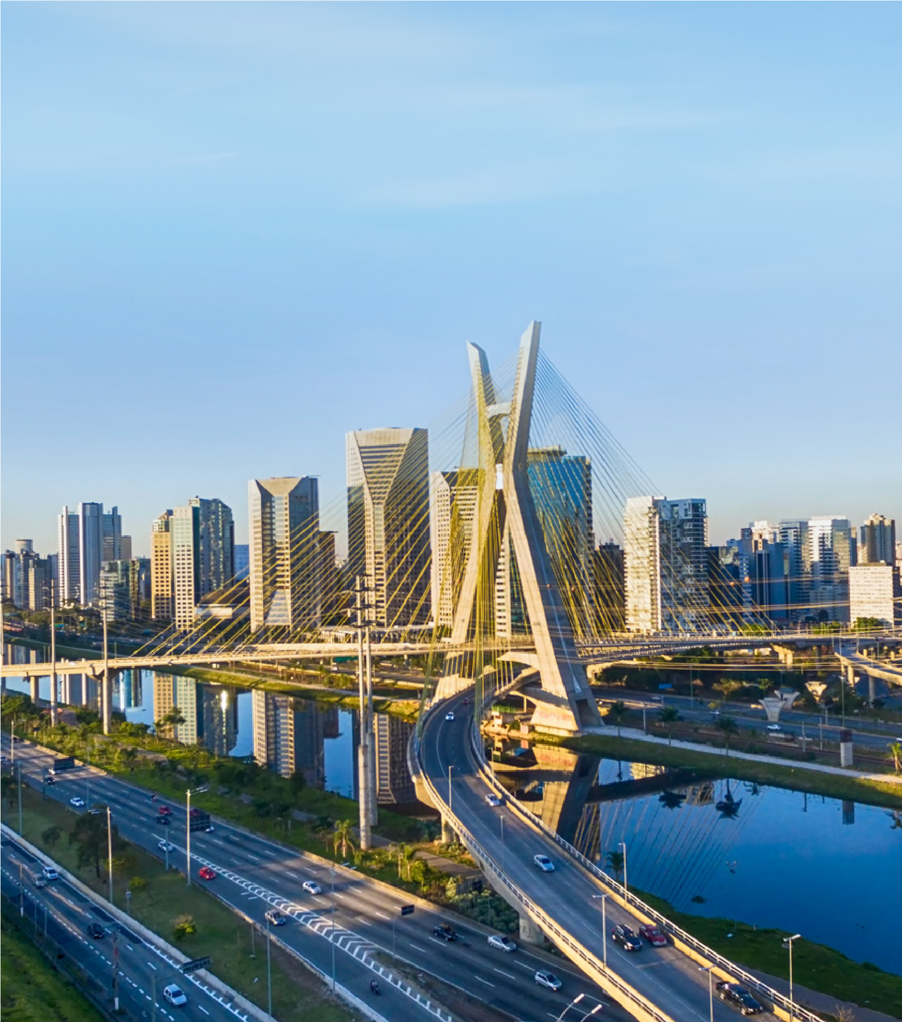
However, a growing list of countries, cities, businesses and other institutions have pledged to meet net-zero emissions. More than 140 countries have set these targets, covering about 88 percent of global emissions, by at least 2050.
There is already a significant drive to develop renewable energy sources from solar power, wind farms and hydro and to move away from carbon energy generation. This will require a significant amount of infrastructure investment, at a time when interest rates are expected to remain high.

Looking beyond interest rates to spur on growth
There are reasons to be optimistic about the outlook, with inflation expected to fall across the globe this year, energy and commodity costs easing and the expectation of lower interest rates.
Healthy investment is continuing in key sectors on a global scale, such as in industrial manufacturing, data centers, healthcare and life sciences, which will help to keep the wheels of growth turning.
Yet the economy remains on an unsure footing and growth is likely to remain subdued. Banks may be slow in reducing interest rates, particularly in the US, which will have knock-on impacts for investment across the world.
Regardless of when rates ease or by how much, policymakers will need to place a sharp focus on improving productivity and maintaining free-flowing global trade to reap the rewards of greater fiscal headroom and restart the engine of growth.
Climate change mitigation policies are expected to drive infrastructure investment in renewable energy, as well as opportunities for domestic and commercial heat pumps and production of electric vehicle batteries. In real estate, there is already a shift in demand for sustainable buildings and this is expected to grow over the decade to come.
For clients looking to reset their capital investment strategies against this backdrop, the next 12 months should offer an increasingly stable environment economically with key opportunities developing in vibrant sectors, green investment areas and emerging economies.

03 | Global construction cost performance

Slow steps forward: gradual acceleration in activity as build costs stabilise

Overview An international ranking – where are the most expensive markets?


Over the past 12 months, inflationary Ten most expensive places to build

pressures, reduced credit availability, tight capital markets and declining affordability have been widespread trends across global construction markets.
Since the beginning of the year, however, most construction markets have been gradually emerging from a period of significant economic difficulty. Countries are now diverging in their reactions to inflationary pressure. While some emerging markets have started to reduce interest rates, the majority are still contending with elevated rates.
Against this volatile backdrop, global construction presents a mixed picture. Geopolitical tensions, disrupted supply routes and increasing shifts towards nearshoring, friend-shoring and onshoring have impacted construction pricing.
Despite these challenges, most markets have maintained steady activity levels over the past year, with fast-growth sectors, attractive locations and hot investment areas helping to hold up overall demand.
According to our data, New York City has retained its position as the most expensive market to build in for the second year running. The average construction cost per m2 stands at US$5,723, up 5.0 percent compared with last year.
San Francisco closely follows in second place, with an average cost of US$5,489 per m2. It similarly retains its position, after dropping


from first place in 2022.
Zurich has surpassed Geneva to claim third place, with an average cost of US$5,035 per m2, up 8.2 percent on the year. Meanwhile, Geneva saw a 7.7 percent increase, averaging US$5,022 per m2.
The top of the table continues to be dominated by US locations with Los Angeles,

Boston, Seattle and Chicago all showing significant increases in cost compared with 2023. Los Angeles has secured fifth place, surpassing Boston, which is now in sixth. Seattle has risen to seventh place, followed by Chicago in eighth.
The ongoing high build costs in US cities are being driven by a range of factors. At a domestic level, robust industry demand has

seen activity grow, coupled with sustained high prices for labor, machinery and equipment.
London has re-entered the top ten in tenth position, with an average cost of US$4,473 per m2. Among the contributing factors of this rise are the growing construction capacity squeeze and the appreciation of the UK pound sterling relative to the US dollar.
Market volatility, tightening financial conditions and decreased affordability have influenced exchange rates significantly. Throughout 2023, many currencies depreciated against the US dollar as a result.
Notably absent from the top ten rankings are Tokyo and Osaka, which have slipped to 14th and 17th position, respectively. Japan has witnessed a significant devaluation of the yen, with the economy experiencing only moderate growth following the pandemic shock. This, paired with strong inflation elsewhere, has contributed to a wider gap. Despite this, the weakened yen has spurred foreign investment. Data centre development is gaining traction alongside large-scale projects such as the Osaka Expo and semiconductor factories in Kyushu and Hokkaido.
Figure 6:

The most expensive places to build (ft²), average cost of eleven building types in USD
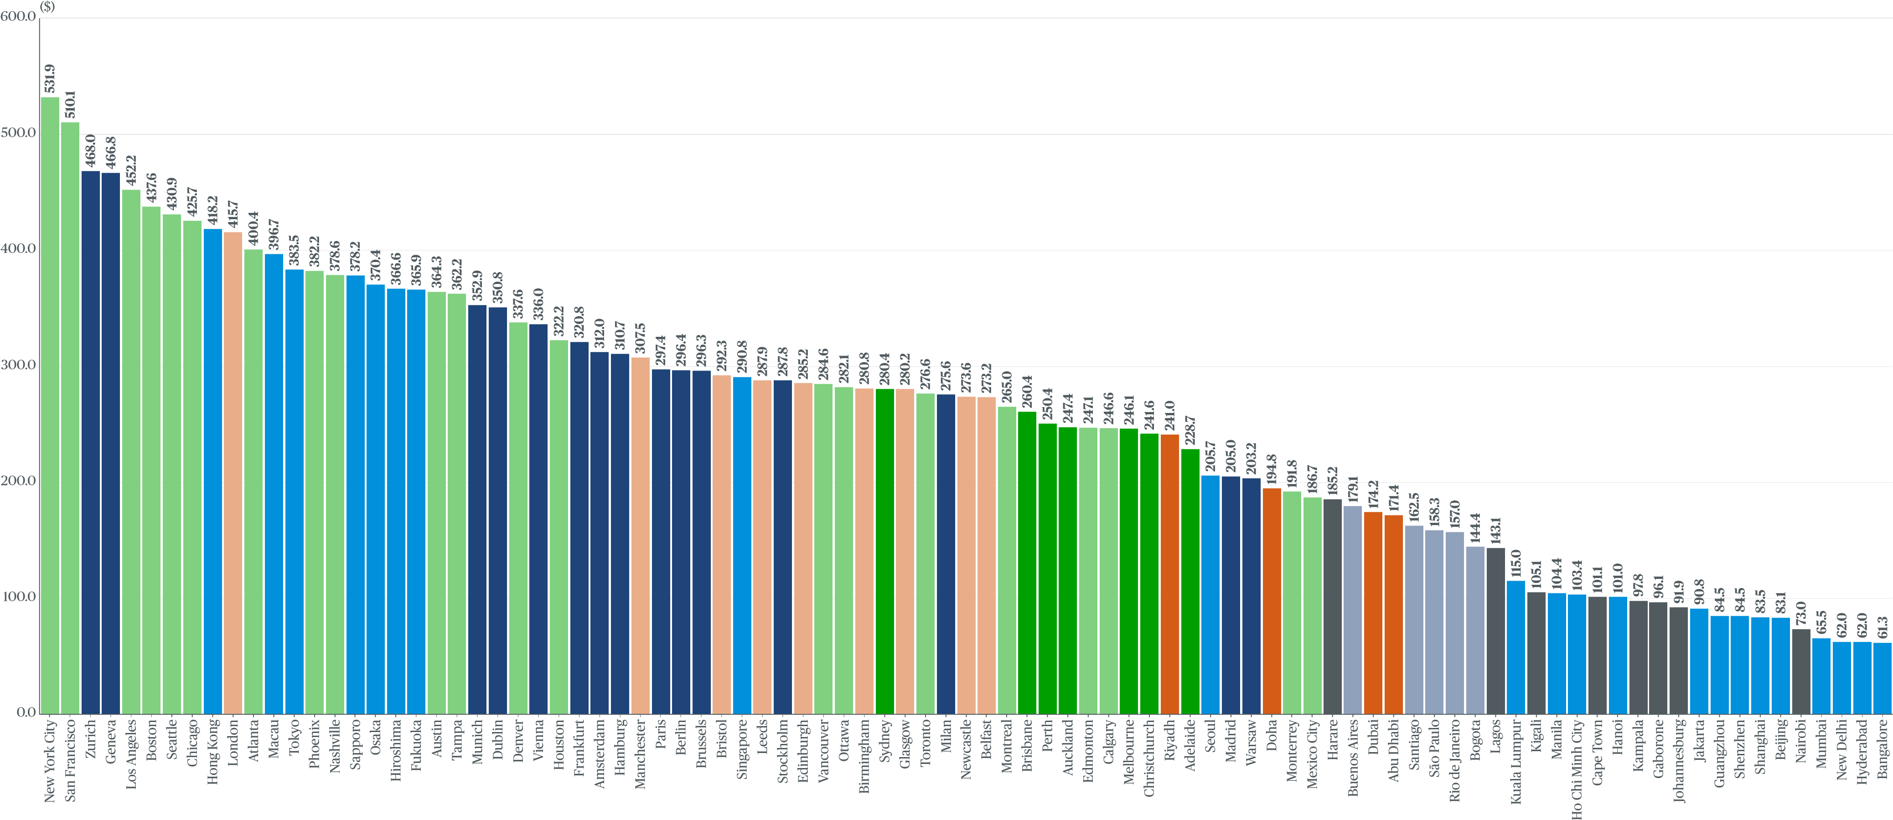
Preliminaries and margins ^{Figure 7:}
Preliminaries and margins (full ranking)
By the end of 2023, inflationary pressures stemming from supply chain disruptions, increased costs of raw materials, transportation and energy costs began to alleviate. | Preliminaries  Market | Margins Market
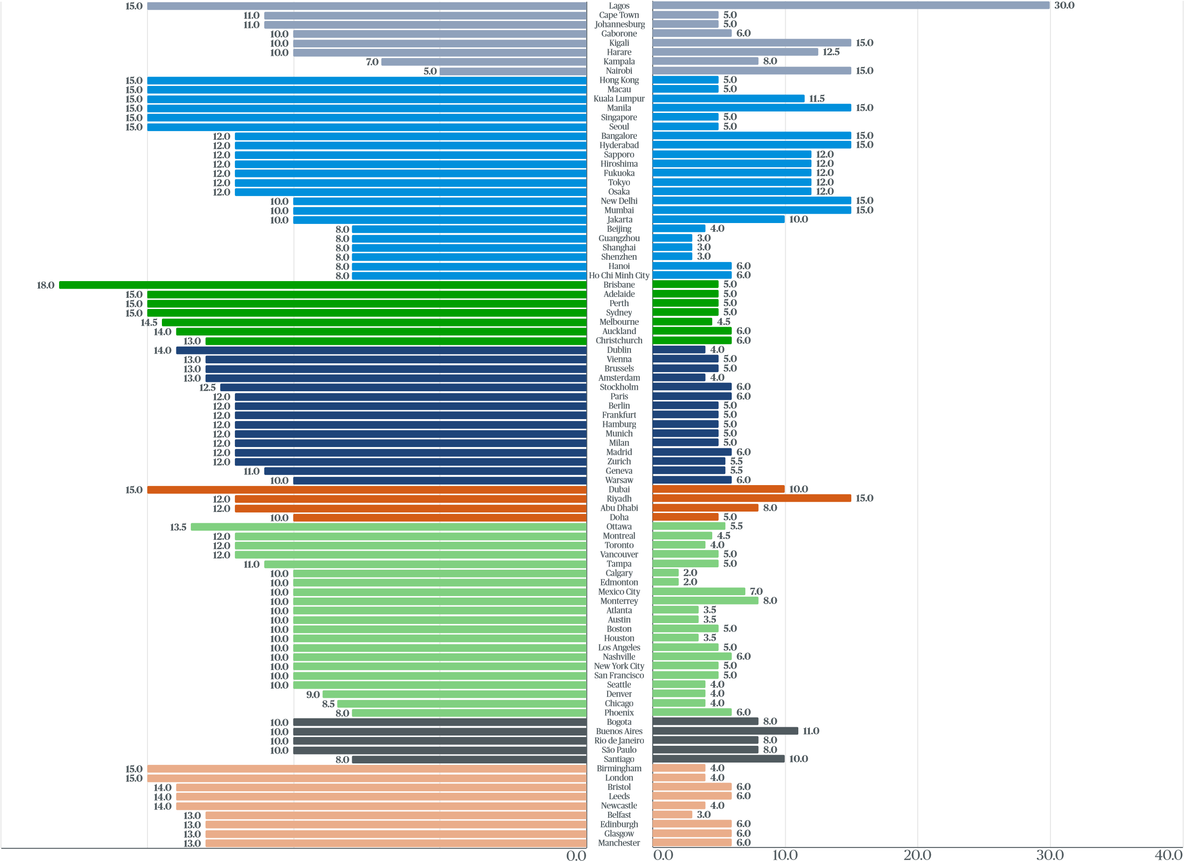
Our construction experts have identified the typical margins on a medium-sized commercial project with a gross floor area (GFA) of 5,000 m² in their local market.
Contractors and supply chains have adapted to the “new normal” following the COVID-19 pandemic and the prolonged conflict in Ukraine. However, new challenges have arisen from increasing geopolitical tensions in the South China Sea, disruptions to shipping in the Red Sea and drought in the Panama Canal. As a result, any potential reductions in prices may not translate into cost savings for those procuring construction work.
Instead, many contractors and elements of the supply chain have sought to recover some of the lost earnings in recent years. Profit margins have consequently continued to rise, perhaps driven more by market conditions than input costs. Additionally, contractors are less able to offer reduced margins to win work, given the financial strain many have come under in recent years.
Profit margins have increased from an average of 6.6 percent in 2023 to 7.0 percent in 2024, though these vary across different regions, with developing economies typically exhibiting higher margins.
Our survey identified the typical preliminary percentage on a medium commercial project with a gross floor area (GFA) of 5,000 m². These also vary by region and country, influenced by factors such as the type of construction, local building standards and the complexity of building sites.
Along with the alleviation of inflationary pressures, preliminary costs have decreased to an average of 11.6 percent in 2024 from 15.5 percent in 2023.
20.0 15.0 10.0 5.0
(%) (%)

Construction cost inflation (CCI) across 2023, 2024 and 2025
Globally, 2023 ended with an average increase of 4.6 percent in construction cost inflation. However, nuances across different regions are evident.
As general consumer price inflation slows in many economies, construction inflation may follow a similar trend. However, there might be differences in the magnitude of change. To understand these differences, it is important to examine the data and consider the different measures of inflation.
Consumer price indices and construction cost indices use different ‘baskets of goods’ for their calculations. Construction cost indices measure those items specific to the sector such as construction labor, materials and plant, while consumer inflation measures a much broader basket made up of a range of items consumers can purchase. Rates of change therefore vary, with consumer price inflation tending to be less volatile and showing slower growth in most economies.
While both measures of inflation typically move in line with economic cycles, construction cost inflation can also be driven by a range of market-specific factors that may influence cost. This can include the level of local construction activity, labor and materials cost and availability, legislation changes and supply chain disruptions.
Africa leads construction cost inflation at an average of 6.6 percent, while North America also displayed higher than usual levels of inflation at 6.1 percent. Europe experienced a modest increase in inflation of 2.8 percent, and, the UK had a slightly lower inflation rate than the global median at 4.2 percent.
The rate of growth in construction costs is showing signs of easing at the global level. On average, construction cost inflation is projected to settle to 3.3 percent globally this year, with all regions anticipating lower inflation compared with 2023.
Africa expects the highest level of construction cost inflation, at a forecasted 5.7 percent in 2024. Lagos notably leads this increase with an estimated rise of 25.0 percent alone. Higher import prices, driven by elevated global inflation and exchange rate passthrough, have impacted domestic prices in Nigeria. The domestic factors were primarily around materials and labor costs. The shift to a market-determined exchange rate also introduced shocks to prices at home. Additionally, security challenges, prolonged infrastructural deficits and expectations of further price increases have contributed to inflationary pressures.
The Middle East follows, expecting construction cost inflation of 4.0 percent in 2024, followed closely by South America and Asia, each with an average of 3.9 percent. Europe anticipates the lowest level of inflation in 2024, with an average of 1.5 percent. The UK follows with construction cost inflation at 3.0 percent. No market is expecting deflation in 2024.
Demand is a primary driver of construction inflation, with increasing client investment and a growing pipeline of work leading to heightened competition among contractors and upward pressure on prices.
Looking ahead, we anticipate that price pressures in the construction sector may not alleviate as rapidly as general inflation, and therefore, construction cost escalation could prove to be persistent across various regions.
Globally, construction costs are anticipated to rise at a similar rate in 2025, by 3.4 percent. However, market differences are evident even within regions. Construction inflation is expected to nudge upwards in North America, Europe, Australia and New Zealand, and Africa, while it is projected to decrease in South America, the Middle East and Asia. In the UK, construction inflation is expected to remain steady in 2025 at 3.0 percent.
Africa is again expected to experience the highest levels of inflation at 5.9 percent on average. North America, Asia, and Australia and New Zealand follow, albeit with some distance, with expected increases of 3.0 percent, 3.8 percent and 3.7 percent in 2025, respectively. Conversely, Europe anticipates the lowest inflation of 1.9 percent in 2025.

Figure 8:

Construction cost inflation across 2023, 2024 and 2025
City CCI 2023 CCI 2024 CCI 2025 |  |  |  |  | City CCI 2023 CCI 2024 CCI 2025 |  |  |  |  | City CCI 2023 CCI 2024 CCI 2025 |  |  |  |  | City CCI 2023 CCI 2024 CCI 2025
Lagos | 30.0% | 25.0% | 20.0% |  | Macau | 4.0% | 3.5% | 3.0% |  | Berlin | 4.0% | 1.0% | 2.0% |  | Vancouver | 7.8% | 3.3% | 3.5%
Cape Town | 7.7% | 6.8% | 5.6% |  | Osaka | 5.5% | 3.5% | 2.5% |  | Frankfurt | 4.0% | 1.0% | 3.0% |  | Edmonton  Atlanta | 8.0%  5.0% | 3.0%  3.0% | 3.5%  4.0%
Johannesburg | 7.7% | 6.8% | 5.6% |  | Hong Kong | 4.0% | 3.0% | 3.0% |  | Hamburg | 4.0% | 1.0% | 2.0%
Kigali | 12.0% | 6.4% | 5.0% |  | Jakarta | 5.0% | 3.0% | 3.0% |  | Munich | 4.0% | 1.0% | 2.0% |  | Los Angeles | 4.5% | 3.0% | 4.5%
Nairobi | 5.0% | 5.0% | 5.0% |  | Kuala Lumpur | 5.0% | 3.0% | 3.0% |  | Brussels | 2.1% | 0.5% | 2.0% |  | Seattle | 5.0% | 3.0% | 3.0%
Gaborone | 4.0% | 4.0% | 5.0% |  | Seoul | 3.3% | 3.0% | 3.0% |  | Amsterdam | 1.5% | 0.5% | 2.0%
 |  |  |  |  |  |  |  |  |  |  |  |  |  |  | Tampa | 3.5% | 3.0% | 3.5%
Harare | 4.0% | 3.0% | 5.0% |  | Hanoi | 1.0% | 3.0% | 3.0% |  | Riyadh | 7.0% | 5.0% | 5.0%
 |  |  |  |  |  |  |  |  |  |  |  |  |  |  | San Francisco | 6.0% | 2.5% | 4.0%
Kampala | 2.2% | 2.5% | 4.0% |  | Brisbane | 6.5% | 5.0% | 5.5% |  | Dubai | 5.0% | 5.0% | 3.0%
 |  |  |  |  |  |  |  |  |  |  |  |  |  |  | Montreal | 6.7% | 2.0% | 3.0%
Fukuoka | 5.0% | 5.0% | 4.0% |  | Perth | 4.9% | 4.0% | 5.0% |  | Abu Dhabi | 4.0% | 4.0% | 3.0%
 |  |  |  |  |  |  |  |  |  |  |  |  |  |  | Bogota | 7.3% | 6.5% | 5.0%
Hiroshima | 5.0% | 5.0% | 4.0% |  | Adelaide | 5.0% | 3.5% | 4.0% |  | Doha | 3.5% | 2.5% | 3.0%
 |  |  |  |  |  |  |  |  |  |  |  |  |  |  | Rio de Janeiro | 3.5% | 4.0% | 3.5%
Tokyo | 5.0% | 5.0% | 4.0% |  | Melbourne | 5.5% | 3.0% | 3.0% |  | Monterrey | 15.5% | 11.5% | 16.5%
 |  |  |  |  |  |  |  |  |  |  |  |  |  |  | São Paulo | 3.5% | 4.0% | 3.5%
Singapore | 8.0% | 5.0% | 5.0% |  | Sydney | 6.0% | 3.0% | 3.5% |  | Mexico City | 13.0% | 10.0% | 12.0%
 |  |  |  |  |  |  |  |  |  |  |  |  |  |  | Buenos Aires | 5.0% | 3.0% | 2.0%
Ho Chi Minh City | 4.0% | 4.5% | 4.5% |  | Auckland | 5.6% | 3.0% | 3.0% |  | Ottawa | 5.5% | 4.5% | 4.0%
 |  |  |  |  |  |  |  |  |  |  |  |  |  |  | Santiago | 3.5% | 3.0% | 3.0%
Beijing | 4.0% | 4.0% | 4.0% |  | Christchurch | 5.6% | 3.0% | 3.0% |  | Austin | 5.5% | 4.5% | 4.0%
 |  |  |  |  |  |  |  |  |  |  |  |  |  |  | Birmingham | 4.5% | 3.5% | 3.5%
Guangzhou | 4.0% | 4.0% | 4.0% |  | Warsaw | 5.5% | 5.0% | 3.0% |  | Calgary | 8.0% | 4.0% | 3.5%
 |  |  |  |  |  |  |  |  |  |  |  |  |  |  | Bristol  Edinburgh | 4.5%  4.0% | 3.5%  3.5% | 3.5%  3.5%
Shanghai | 4.0% | 4.0% | 4.0% |  | Dublin | 3.0% | 3.0% | 2.0% |  | Chicago | 5.0% | 4.0% | 4.0%
Shenzhen | 4.0% | 4.0% | 4.0% |  | Madrid | 2.0% | 3.0% | 3.0% |  | Denver | 5.0% | 4.0% | 3.0%
 |  |  |  |  |  |  |  |  |  |  |  |  |  |  | Glasgow | 4.0% | 3.5% | 3.5%
Bangalore | 4.5% | 4.0% | 5.0% |  | Paris | 2.4% | 2.5% | 1.0% |  | Houston | 4.5% | 4.0% | 3.0%
 |  |  |  |  |  |  |  |  |  |  |  |  |  |  | Manchester | 4.5% | 3.5% | 2.0%
Hyderabad | 4.5% | 4.0% | 5.0% |  | Milan | 1.5% | 2.0% | 2.0% |  | Nashville | 5.0% | 4.0% | 3.0%
 |  |  |  |  |  |  |  |  |  |  |  |  |  |  | Newcastle | 4.0% | 3.5% | 3.0%
New Delhi | 4.5% | 4.0% | 5.0% |  | Geneva | 2.4% | 2.0% | 1.0% |  | Phoenix | 5.0% | 4.0% | 3.0%
Mumbai | 4.5% | 4.0% | 5.0% |  | Zurich | 2.6% | 2.0% | 1.0% |  | Toronto | 6.0% | 3.5% | 4.0% |  | Leeds | 4.0% | 3.0% | 3.0%
Sapporo | 6.3% | 4.0% | 3.0% |  | Stockholm | 2.0% | 1.5% | 2.5% |  | Boston | 6.0% | 3.5% | 2.5% |  | Belfast  London | 4.5%  3.5% | 2.0%  2.0% | 3.0%  2.8%
Manila | 5.0% | 4.0% | 4.0% |  | Vienna | 3.5% | 1.0% | 2.0% |  | New York City | 6.0% | 3.5% | 3.5%
Input costs  Labor  A global rise in labor costs, brought on by | Figure 9:  Availability of construction labour by region  Africa | Asia | Australia and New Zealand
laborious. | Europe | Middle East | North America
persistent labor shortages, is exerting upward pressure on overall construction expenses. Skilled construction labor remains scarce in most developed nations, exacerbated by an ageing workforce, high retirement rates and insufficient recruitment of young people seeking careers in construction.
(
%
)
0.0
50.0
100.0
Skills shortage
In balance
Surplus

25.0

12.5

62.5
(
%
)
0.0
50.0
100.0

90.9

0.0

9.1
0.0
50.0
100.0
(
%
)
100.0

0.0

0.0
Following the COVID-19 pandemic, numerous construction workers have also migrated to different industries where work is perceived as less
(
%
)
0.0
50.0
100.0
Skills shortage
In balance
Surplus

0.0

60.0

40.0
(
%
)
0.0
50.0
100.0

79.1

11.0

9.9
(
%
)
0.0
50.0
100.0
100.0

0.0

0.0
Critical levels of labor shortages remain in Australia and New Zealand and the UK. Skills shortages have also become more pronounced in North America with 91 percent of respondents identifying labor as an acute issue.
(
%
)
0.0
50.0
100.0
Skills shortage
In balance
Surplus

86.7

13.3

0.0
(
%
)
0.0
50.0
100.0

50.0

50.0

0.0
)
(
%
0.0
50.0
100.0

90.5

9.5

0.0
Conversely, labor availability has slightly improved in South America, though demand for high-tech projects in major regional markets such as Bogota and Santiago is leading to a growing number of skilled
workers being imported from other regions. South America Total UK

Low unemployment rates are driving up labor costs in many
developed markets, including Australia, Europe, the US and Canada.
Subcontractors for specialized jobs such as mechanical and electrical
are facing significant strains in Japan and the UK in particular.
Conversely, developing and emerging markets are experiencing higher
unemployment rates while grappling with the lingering effects of the
pandemic and various geopolitical tensions. Regions such as Africa,
South America and some markets in eastern Europe show a better
balance between job vacancies and the available workforce, which is
helping to maintain stability in labor costs.
To assess inflationary pressures stemming from labor issues, we gather
wage data across our markets and evaluate their impact on projects
and Programs. Our 2024 survey findings have been influenced by
exchange rate fluctuations, yet they consistently reveal an increase
in construction wages over the past 12 months. Examining changes
in domestic currency provides clearer insights into underlying trends,
with labor costs averaging a 4.6 percent rise over the past year, slightly
below the growth levels observed between 2022 and 2023.
As a result of higher consumer price inflation, the industry has
encountered sustained pressures to raise salaries, further contributing
to the inflationary challenges faced by construction companies.
Africa
Asia
Australia and New Zealand
Europe
Middle East
North America
South America
UK
$3.49
$12.69
$58.74
$68.64
$6.97
$75.13
$5.56
$49.46
Figure 10:
Average hourly wage (USD) by region

Materials
Although still rising, the prices of key construction materials have experienced some relief, decreasing from the exceptionally high levels of price growth seen in previous years. For example, the reduction in the cost of iron ore has had a positive impact on steel prices. Additionally, the pandemic-related disruptions to supply chains have eased, and the return of shipping costs to pre-pandemic levels is supporting the stabilization in building material costs.
Nevertheless, geopolitical tensions and ongoing conflicts continue to pose a threat to the global supply chain. These ongoing risks, along with lessons learned from the COVID-19 pandemic, are prompting some economies to reconsider their trade strategies and relocate some production activities closer to home. In efforts to mitigate risks associated with supply chain dependence, the US has explored Mexico as an alternative for certain components previously imported from China. Similarly, India, Indonesia and several African countries have emerged as global alternatives for material manufacturing.
We expect that, over the coming years, we will continue to see the move away from globalized supply chains with more friendshoring and onshoring taking place. While this might provide greater supply chain certainty, it could also add additional costs as domestic production may involve higher labor and plant expenses. However, some positive reductions might result from shorter shipping distances, which would also decrease projects’ embodied carbon footprints.

Figure 11:  Percentage change between 2023 and 2024 in key materials, global average  Category | Plant  We measure plant costs as day hire rates, considering labour, consumables (e.g. fuel) and sales tax for a 50-tonne mobile crane
0.0
2.0
4.0
6.0
8.0
10.0
12.0
14.0
Reinforcement bar 16mm
tonne) (120 tonne job
(
)
mm plasterboard
13
)
m²
(
Glass pane 10mm tempered
)
m²
(
Concrete 30 MPa
)
m³) (1,500m³ job
(
Concrete block – 400 x 200 x 100 tk solid blocks
– cost per 1,000 blocks
(
for schemes with > 10,000 blocks
)
Structural steel beams
)
tonne) (100 tonne +job
(
Softwood timber for framing
)
100
mm X 50mm (m
Copper cable (metre)
(3
C + E, 2.5mm PVC) (100,000m+ job
)
Copper pipe 15 mm
)
metre) (1,000+ metre job
(
Standard brick per 1,000
Emulsion paint
)
litre
(
with an operator per day. Our data indicates
that plant costs have risen by 3.4 percent
compared with last year, as have overall
operational costs of plant, machinery and
equipment. As well as inflationary pressure
from the labour market, some of these
increases can be attributed to the growth
in oil prices. The cost of oil has a strong
interdependency with economic cycles. When
economic activity rises, so does the demand
for oil, causing its price to surge. According
to data from the
World Ban
k
, the price of
Brent crude oil has escalated by 8.8 percent
between March 2023 and March 2024.
Oil stands out as one of the world's most
volatile commodities, in part because
many oil-producing regions, including the
Middle East, Latin America and Russia,
are experiencing political turbulence. The
heightened risk of regional crises leads to
global oil price fluctuations, which impact
energy markets and economies worldwide.
(%)
Tendering conditions and construction outlook  Assessing current tendering conditions and anticipating how these may change provides valuable insights into what stage of | Figure 12:  Regional construction tendering conditions  Africa | Asia | Australia and New Zealand
the cycle a construction market is at and can be a key indicator of future cost inflation.

0.0

40.9

31.8

27.3

0.0
0.0
10.0
20.0
30.0
40.0
50.0
60.0
70.0
(
%
)

0.0

50.0

50.0

0.0

0.0
0.0
10.0
20.0
30.0
40.0
50.0
60.0
70.0
Cold
Lukewarm
Warm
Hot
Overheating
%
)
(

Europe

0.0

28.6

57.1

14.3

0.0
0.0
10.0
20.0
30.0
40.0
50.0
60.0
70.0
(
%
)

20.0

0.0

40.0

40.0

0.0
0.0
10.0
20.0
30.0
40.0
50.0
60.0
70.0
(
%
)

0.0

66.7

33.3

0.0

0.0
0.0
10.0
20.0
30.0
40.0
50.0
60.0
70.0
Cold
Lukewarm
Warm
Hot
Overheating
(
%
)
0.0
10.0
20.0
30.0
40.0
50.0
60.0
70.0

4.8

14.3

61.9

19.0

0.0
(
%
)
In markets where tendering conditions are classified as cold or lukewarm, intense competition among contractors for fewer available projects is common, leading to heightened commercial tension, which often drives prices down. Conversely, hot or overheating tendering conditions typically signify markets with robust project pipelines and full order books, which can push up margins and labor costs and drive higher construction costs.
46.2 percent of our surveyed markets reported warm
tendering conditions. This aligns with the findings of Middle East North America our 2023 survey, when 48.3 percent of respondents also identified warm tendering conditions as prevalent across markets.
At the global scale, tendering conditions are notably warm, exerting downward pressure on construction costs. Central banks globally responded to elevated general inflation by increasing interest rates, consequently dampening investment for construction projects. This trend affected most markets, placing them within the warm and lukewarm regions.
In 2023, 25.8 percent of respondents identified tendering conditions as either cold or lukewarm. However, in 2024,

South America Total United Kingdom
this proportion increased to 39.6 percent. Only 3.3 percent of markets reported cold tendering conditions, primarily attributable to specific circumstances such as political uncertainty in Santiago, which has hindered foreign and local investment.
70.0
0.0
10.0
20.0
30.0
40.0
50.0
60.0

0.0
22.2

0.0

0.0
(
%
)

3.3

36.3

46.2

14.3

0.0
0.0
10.0
20.0
30.0
40.0
50.0
60.0
70.0
(
%
)

20.0

60.0

20.0

0.0

0.0
0.0
10.0
20.0
30.0
40.0
50.0
60.0
70.0
Cold
Lukewarm
Warm
Hot
Overheating
%
)
(
100.0
At the same time, the proportion of markets seeing hot or overheating tendering conditions decreased from 25.8 percent in 2023 to 14.3 percent this year. Most of these are markets that have experienced a release of pent-up demand following periods of volatile inflation and tightening financial conditions such as New York City, Ottawa and Dubai.
Looking ahead, 42.9 percent of markets anticipate conditions to stay the same, while 35.2 percent expect conditions to get warmer.  This marks an improvement from last year, | Figure 13  Regional construction market outlook  Africa | Asia | Australia and New Zealand
a sentiment of new opportunities within the
industry. | Europe | Middle East | North America
when more than half of respondents, 56.2 percent, expected market conditions to stay the same. Additionally, the number of people expecting warmer market conditions has increased by 8.2 percentage points on the year.

0.0

25.0

75.0
0.0
50.0
100.0
Cooler
Warmer
Staying the same
(
%
)

4.5

18.2

77.3
0.0
50.0
100.0
(
%
)

28.6

42.9

28.6
0.0
50.0
100.0
(
%
)
For most markets, the potential for a recession has receded, and though growth remains subdued, signs of progress are emerging. Several countries and regions will undergo elections this year, bringing promises of investment to the forefront and fostering
However, a notable proportion of markets, 22.0 percent, anticipate their markets will cool down. This increased from 16.9 percent in 2023. Primarily, these are European markets that have encountered heightened inflationary pressures and disruptions in the supply chain due to the conflict in Ukraine.

73.3

26.7

0.0
0.0
50.0
100.0
Cooler
Staying the same

25.0

0.0

75.0
0.0
50.0
100.0

9.5

81.0

9.5
0.0
50.0
100.0
Warmer
(
)
%
(
%
)
(
)
%

South America Total United Kingdom

40.0

20.0

40.0
0.0
50.0
100.0
Cooler
Staying the same

22.0

42.9

35.2
0.0
50.0
100.0

11.1

88.9

0.0
0.0
50.0
100.0
Warmer
)
%
(
(
%
)
(
)
%

Looking ahead
There are reasons to be optimistic as we turn our attention to the second half of 2024 and beyond. As consumer price inflation gets under control across each economy, we expect to see the implementation of supportive policy setting, which for most markets could be a trigger for private sector construction investment.
Additionally, we expect there to be fiscal stimulus from governments to prompt public investment across the construction sector, which for many is a substantial contributor to economic growth.

There are also several key sectors poised to see sizeable growth in the years ahead. This includes data centers and advanced manufacturing facilities, driven by the continued advancement in technologies and the drive to net zero. The renewable energy sector is likely to continue to expand, as will life sciences, driven by an ageing population and advancements in biopharmaceuticals.
Skills shortages are one of the most significant challenges we foresee with a growing need for the construction sector to improve productivity and efficiency. Addressing these challenges will open up the possibility of cheaper construction costs, which in turn will help to ensure the growth of global construction markets.
The outlook is not without risks and challenges. The construction workforce is structurally shrinking with the sector continuing to see more retirees than fresh entrants. Additionally, construction cost inflation continues to be a constraint impacting the feasibility and viability of new projects.

04
| Regional insights and data
A view from around
the globe

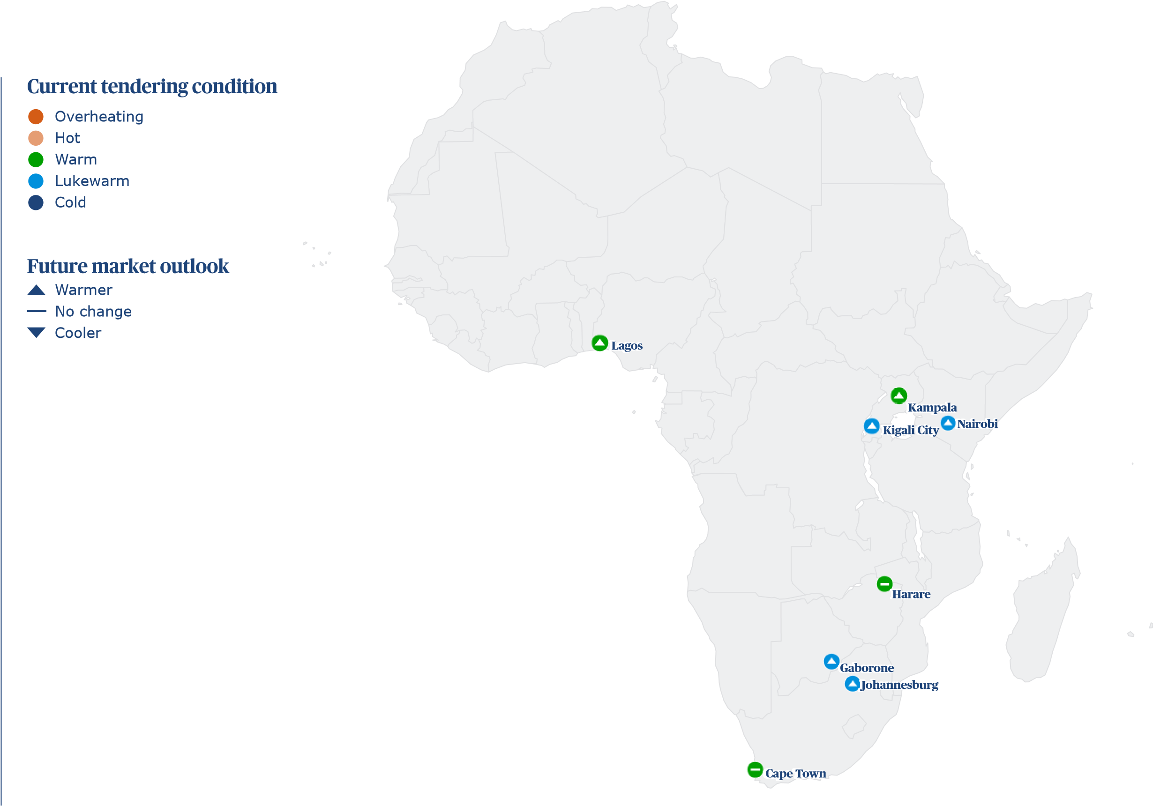
A continent in transition
Author: Wendy Cerutti, Regional Real Estate Lead, Africa
Propelled by rapid population growth, economic activity across many parts of Africa is accelerating, and investment in digital infrastructure, retail and commercial is increasing. However, significant hurdles to growth remain across the continent.
Africa
Surging population growth is set to radically reshape economies across Africa. The United Nations forecasts that, by 2050, 2.5 billion people will live in Africa, accounting for more than a quarter of the world’s population.
High birth rates mean a significant proportion will soon enter the workforce and start contributing to economic activity. According to the International Monetary Fund’s April Outlook, GDP growth is set to pick up in 2024 to 3.8 percent in sub-Saharan Africa, and then again in 2025 to 4.0 percent.
Despite this labor boost, specialist skills for construction remain in comparably short supply in many locations – a situation that was exacerbated by the COVID-19 pandemic, when many overseas consultants and contractors left the market. This is made clear by the hourly wages paid to site foremen in major cities, which are significantly higher than the salary for other roles. In Cape Town, a key investment market, they earn US$14.6 per hour, compared with the US$6.2 average.

making the difference

Dislocated supply chains, along with a persistent stop-start cycle of financing, delayed approvals, and bureaucratic complexities, continue to challenge construction programs. One consequence has been an increase in programs lengths – with delays commonly stretching to over five weeks in Nairobi, Lagos, Cape Town and Harare.
Despite the challenges, demand for construction services is only set to grow, given the urgently increasing need for real estate and infrastructure to serve the continent’s booming population and accelerating digitalization, as the internet becomes increasingly accessible.

Regional construction key challenges
Africa
0.0
20.0
40.0
80.0
100.0
60.0
Difficult contractual and legal conditions
Low workplace productivity, inefficient and
Net-zero commitments
Political instability
Institutional instability
The market is oversupplied, e.g. too many
Increasing contractor insolvency
Lack of confidence in the market
Difficulties accessing credit
Skilled labour shortages
Excessive materials lead-in times
Too many contractors chasing too few projects
Economic instability
Rising costs of construction
Government red tape, bureaucracy,
to invest in new projects
vacant apartments and office space
outdated work practices
Little impact
Fair impact
Medium impact
Large impact
Major impact
delayed approvals
(%)

Construction cost escalation in hot sectors
In Johannesburg, it comes with a price tag of US$1,146.2 per m², compared with US$1,130.1 per m² in 2023.
In South Africa, this is already translating into sustained investment which, when combined with a general inflationary environment, is creating cost escalation: in Cape Town and Johannesburg, average costs are forecast to increase by 6.8 percent this year, although this is a reduced rate compared to the 7.7 percent seen in 2023.
Demand for commercial space is a contributing factor. As expectations for the workplace increase, the cost to build a high-rise prestige office in the center of Cape Town is now US$1,284.1 per m², up from US$1,265.1 per m² last year.
Recovery in the tourism sector is also fueling activity. Building a five-star hotel now costs US$1,629.0 per m² in Cape Town, and US$1,549.5 per m² in Johannesburg. Elsewhere, too, the opportunity to attract increasing visitor numbers is generating work. In Lagos, the cost to build a luxury resort is US$1,923.0 per m².
Throughout the continent, the need for data centers to keep up with growing demand for IT infrastructure is also being recognized. Construction hubs include Kenya, Nigeria and South Africa. In Nairobi, the cost of data center construction is US$8.49 per watt, according to our 2023 Data center cost index.
Some clients are tackling the impacts of these rising prices by building data centers in bordering countries, where costs may be lower. For example, many developers are looking to Ghana, where construction is more affordable than Nigeria, though close enough for the Nigerian population to benefit from centers’ data capacity.
How do you think supply chain will perform in the coming 12 Approximately, how has program length changed over the last 12 months? months?
Africa

0.0

50.0

50.0
Weaken
Improve
Staying
the same

0.0

25.0

75.0
Decreased
Increased
Stayed
the same
0.0 50.0 100.0 0.0 50.0 100.0
(%) (%)

Power security is still some way off
Power security remains a critical challenge across real estate sectors, including in South Africa, where load shedding continues to be a feature of daily life.
The high energy demands of the data centre industry have typically been satisfied by prioritising these increasingly essential assets in the queue for connection with national power grids, and back-up generators when required.
Governments are working to address energy stability while also attracting private sector investment in alternative sources. Hydrogen, for example, is being considered as an option to keep up with growing energy needs across the continent. South Africa’s planned Hydrogen Corridor is set to include nine separate projects between Mokopane, Johannesburg and Durban, supporting mining in the region and boosting the country’s supply of clean energy.
With many parts of Africa boasting ample sunshine hours, solar power is another obvious resource. This is being explored throughout the continent, and workers who can install solar panels are highly sought after as a result. Across all African locations surveyed, this is cited as the most in-demand green skill in construction.

Growing project pipelines
In all locations, however, under 50 percent of projects are committed to net-zero carbon, according to our data. While environmental regulation remains light overall, awareness of climate issues within the political consciousness is growing. With nations across the continent due to head to the polls this year, we could expect to see new sustainability pledges from governments, which may impact investment.
Africa
For the construction industry, political change will affect more than just the importance placed on the road to net zero. Over the next year, it could also result in more public sector tenders, adding to the increasing opportunities for work being created across Africa. Survey respondents across most locations expect the market to get warmer over the next year.
The sector will need to prepare for the coming pipeline of work. The opportunities for the construction industry are not just set to grow in number, but also in complexity, as economic headwinds prevail and new priorities, including environmental issues, become increasingly important considerations.
Getting ahead of the curve will require the sector to start laying long-term plans and thinking proactively and innovatively about the ways that market challenges can be mitigated. Investment in digital tools, for example, will help the industry to address a shortfall of high-skilled labor – propelling efficiency and accelerating delivery for rapidly expanding communities.
A regional ranking – where are the most expensive markets?

Most expensive place to build (ft²), average cost of eleven building types in USD
Market
(
$
)

185.2

143.1

105.1

101.1

97.8

96.1

91.9

72.9
0.0
100.0
200.0
300.0
400.0
500.0
600.0
Harare
Lagos
Kigali
Cape Town
Kampala
Gaborone
Johannesburg
Nairobi

Africa
Construction market metrics
Cape Town |  | Gaborone | Harare | Johannesburg | Kampala | Kigali | Lagos | Nairobi | Nairobi
Tendering: | Warm | Lukewarm | Warm | Lukewarm | Warm | Lukewarm | Warm | Lukewarm | Cold
Market: | Staying the same | Warmer | Staying the same | Warmer | Warmer | Warmer | Warmer | Warmer | Cooler
Inflation 2023: (%) | 7.7 | 4.0 | 4.0 | 7.7 | 2.2 | 12.0 | 30.0 | 5.0 | 5.0%
Inflation 2024: (%) | 6.8 | 4.0 | 3.0 | 6.8 | 2.5 | 6.4 | 25.0 | 5.0 | 10.0%
Inflation 2025: (%) | 5.6 | 5.0 | 5.0 | 5.6 | 4.0 | 5.0 | 20.0 | 5.0 | 8.0%
Contractor's margin: (%) | 5.0 | 6.0 | 12.5 | 5.0 | 8.0 | 15.0 | 30.0 | 15.0 | -5.0%
Preliminaries: (%) | 11.0 | 10.0 | 10.0 | 11.0 | 7.0 | 10.0 | 15.0 | 5.0 | 15.0%
Location Index (London = 100): | 24.3 | 23.1 | 44.5 | 22.1 | 23.5 | 25.3 | 34.4 | 17.5 | 4.0%
Location index (London = 100): | 25.8 | 26.3 | 32.1 | 40.7 | 23.2 | 25.4 | 29.6 | 56.0 | 18.8
Regional construction cost performance
   | Johannesburg | Johannesburg | Nairobi | Nairobi
  International building costs per ft² of internal area | ZAR | US$ | KES | US$
  Commercial
  Labour, material and plant costs | Johannesburg  ZAR | Johannesburg  US$ | Nairobi  KES | Nairobi  US$
  Labour costs (rates per hour)
CBD Offices – high-rise prestige 2,007 107 12,268 93 Group 1 Tradesman e.g. plumber/electrician 116 6 250 2
Africa
Group 2 Tradesman e.g. carpenter bricklayer | 90 | 5 | 250 | 2
Group 3 Tradesman e.g. carpet layer, tiler, plasterer | 90 | 5 | 250 | 2
Group 4 Green collar installation operative e.g. insulation/ solar/heat pump | 116 | 6 | 300 | 2
General labourer | 65 | 3 | 100 | 1
Site foreman | 272 | 14 | 375 | 3
Material costs
13 mm plasterboard (m²) | 98 | 5 | 585 | 4
Concrete 30 MPa (m³) (1500m³ job) | 1,987 | 105 | 11,400 | 87
Concrete block (400x200) per 1000 (>10,000 block job) | 8,200 | 435 | 55,000 | 419
Copper cable (metre) (3C + E, 2.5mm PVC) (100,000m+ job) | 50 | 3 | 450 | 3
Copper pipe 15 mm (metre) (1000+ metre job) | 129 | 7 | 1,600 | 12
Emulsion paint (litre) | 50 | 3 | 950 | 7
Glass pane 10mm tempered (m²) | 1,750 | 93 | 7,000 | 53
Reinforcement bar 16mm (tonne) (120 tonne job) | 22,664 | 1,203 | 136,000 | 1,036
Softwood timber for framing 100mm X 50mm (m) | 97 | 5 | 900 | 7
Standard brick per 1000 | 2,520 | 134 | 49,000 | 373
Structural steel beams (tonne) (100 tonne+ job) | 31,715 | 1,683 | 160,000 | 1,219
Plant costs (rates per day)
Hire 50t mobile crane + operator (day) | 13,600 | 722 | 100,000 | 762
CBD Offices – up to 20 floors medium (A-Grade) | 1,608 | 85 | 8,783 | 67
Education
Primary and secondary | 1,022 | 54 | 4,647 | 35
General Hospital (e.g. city teaching hospital) | 2,955 | 157 | 13,290 | 101
Hotels
3-Star travellers | 1,868 | 99 | 13,197 | 101
5-Star luxury | 2,714 | 144 | 16,078 | 123
Resort style | 2,630 | 140 | 14,638 | 112
Industrial
Advanced manufacturing facility | 1,673 | 89 | 10,734 | 82
Large warehouse distribution centre | 678 | 36 | 6,506 | 50
Retail
Large shopping centre including mall | 1,775 | 94 | 7,435 | 57
Neighbourhood incl supermarket | 1,310 | 70 | 6,506 | 50
Prestige car showroom | 1,459 | 77 | 7,807 | 59
Residential
Apartments high-rise | 1,896 | 101 | 6,506 | 50
Townhouses medium standard 1,097 58 5,576 42

Shifts in the manufacturing heartlands
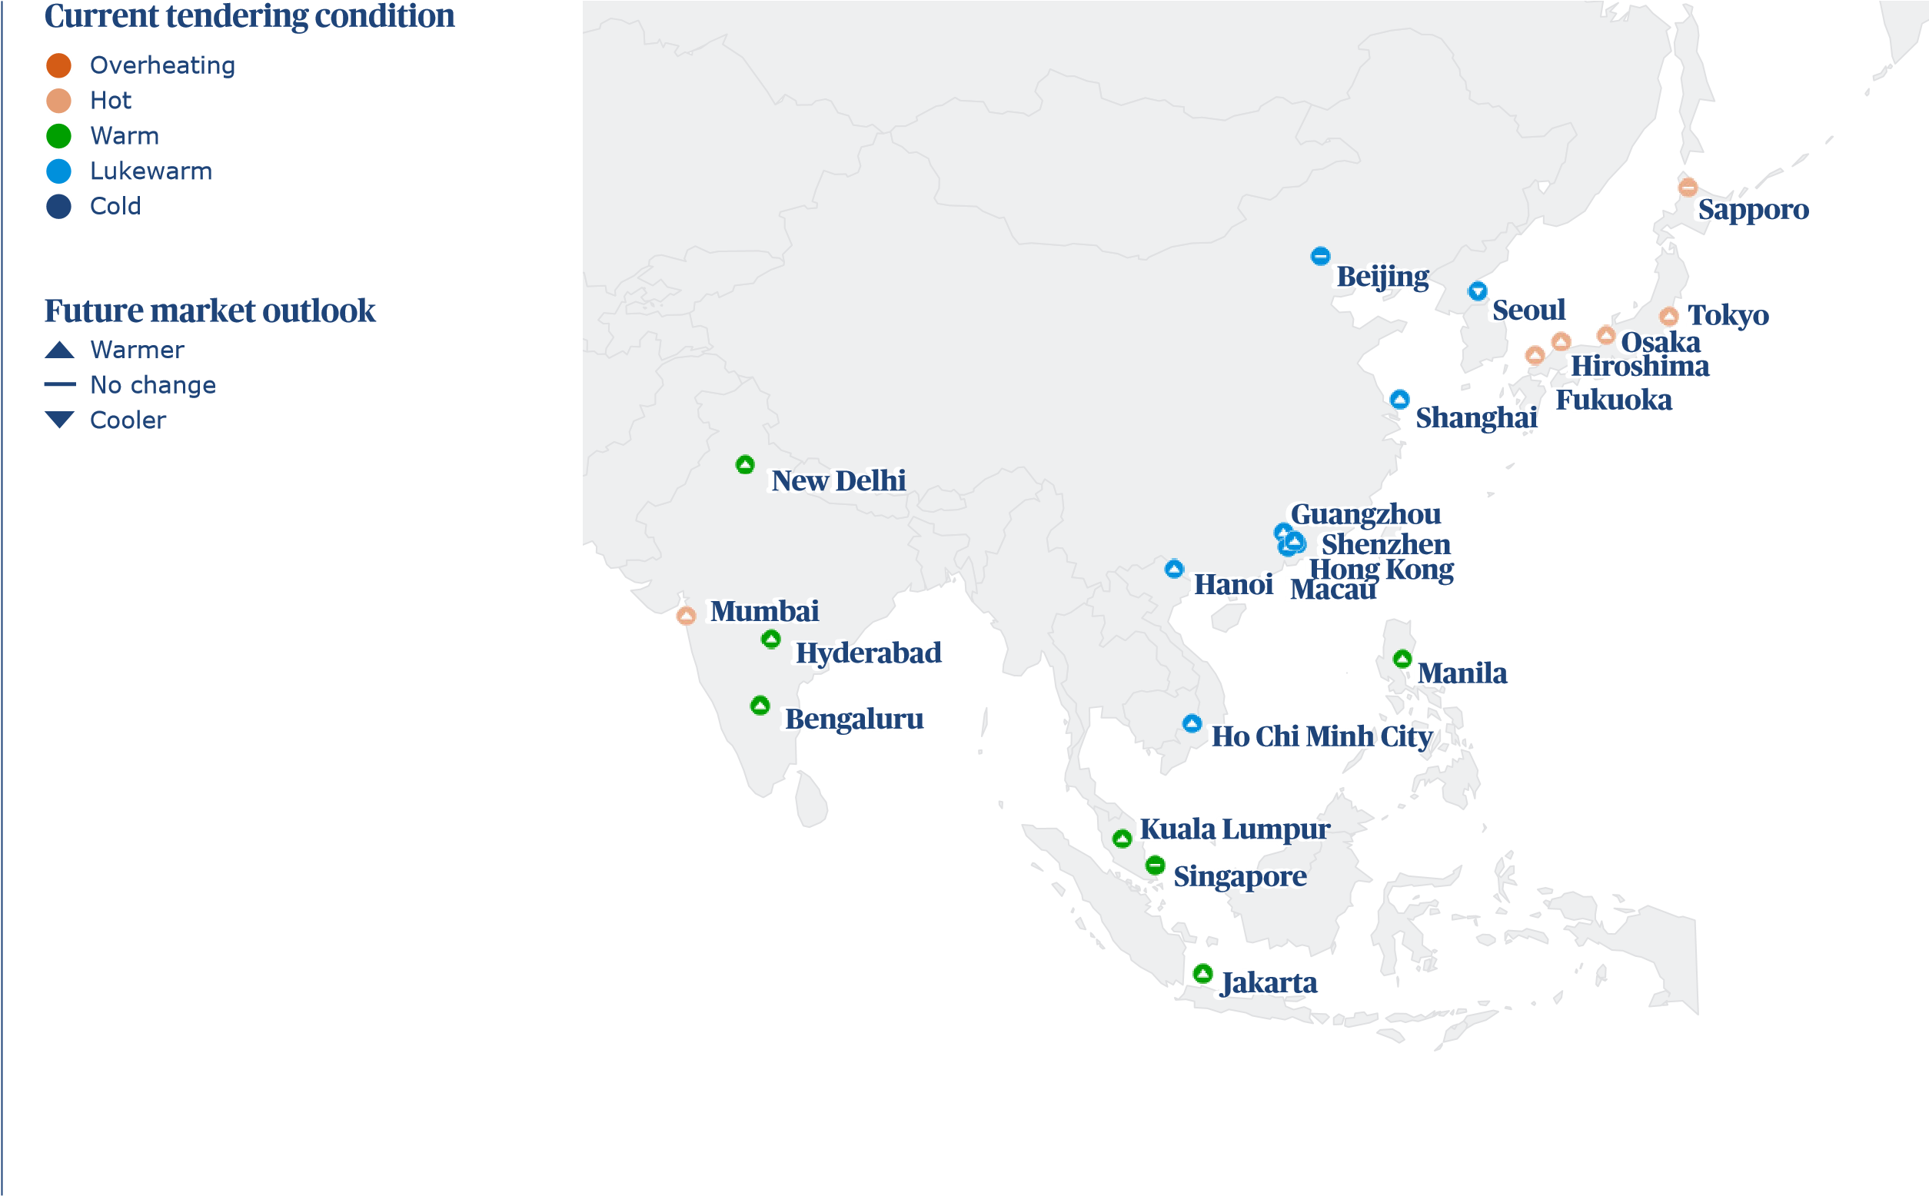
Author: Sumit Mukherjee, Regional Real Estate Lead, Asia
An economic slowdown in China and global trends towards nearshoring are reshaping the Asian market and opening up new opportunities for emerging economies.
Asia
In previous years, the gap in maturity between so-called ‘established’ and ‘emerging’ markets has meant divergent economic and construction trends. Yet, in 2024, Asia is seeing more consistent shifts across the region.
The rebalancing of China’s economic dominance and manufacturing sector is a major factor. GDP growth in the country is expected to slow 4.6 percent in 2024 from 5.2 percent last year, according to the IMF’s April 2024 World Economic Outlook.
In March, inflation sat at just 0.1 percent. The Chinese government’s response to its economic challenges is not yet clear, making the future of the market unpredictable and dampening investment confidence. In the construction sector, most Chinese markets remain near the bottom of the overall cost table, with the expected exception of the unique and expensive Hong Kong (at an average US$4,500 per m²) and Macau (US$4,269 per m²) markets. China’s abundant labor force continues to keep costs low in mainland markets.

making the difference
Japan, which has often seen its cities come top of the ICMS ranking for construction cost, no longer has any markets in the top 10. This is more a reflection of globally high inflation, the devaluation of the yen and the country’s comparative ability to manage escalation while supporting high growth in industries including data centers, advanced manufacturing, retail and urban development. Osaka – the world’s 17th most expensive market to build in at US$3,985 – is seeing a development boom as it prepares for EXPO 2025.
Asia
Net-zero commitments
Institutional instability
Too many contractors chasing too few projects
Political instability
Difficult contractual and legal conditions
Low workplace productivity, inefficient
The market is oversupplied, e.g. too many
Difficulties accessing credit
Economic instability
Increasing contractor insolvency
Lack of confidence in the market
Government red tape, bureaucracy,
Excessive materials lead-in times
Rising costs of construction
Skilled labour shortages
delayed approvals
to invest in new projects
vacant apartments and office space
and outdated work practices
Little impact
Fair impact
Medium impact
Large impact
Major impact

Regional construction key challenges

0.0 20.0 40.0 60.0 80.0 100.0
(%)

Moving centers of manufacturing and tech
India, in particular, is seeing strong industrial investment as it looks to take over from China as the region’s economic leader – and this is reflected in the rise in relative construction costs.
The position of China has seen other markets move on the opportunities in advanced manufacturing, an area which has long been a cornerstone of the Asian economy – especially chips, semiconductors and gigafactories. A trend towards nearshoring has helped stimulate demand for local manufacturing bases to reduce reliance on cross-border trade.
In overall cost terms, Indian markets tend to see lower prices than Chinese ones, yet predicted construction cost inflation is greater in India, and when it comes to industrial construction specifically, India is higher up the table. In Bangalore, for example, advanced manufacturing construction costs are now US$1,861 per m², compared with US$568 per m² in Shenzhen.
Malaysia and Indonesia are also seeing high growth in manufacturing as part of this shift, and in Jakarta, the cost of advanced manufacturing construction has sharply risen.
Malaysia especially is making the most of another trend too – the growth of data centers across Asia. Corporates across the region are moving to more cloud-based solutions, and the Asian population has increasing access to broadband, meaning much greater digital infrastructure is needed.

How do you think supply chain will perform in the coming 12 Approximately, how has program length changed over the last 12
Asia
months? | months?
0.0

0.0
50.0

63.6
50.0

36.4
Weaken
Improve
Staying
the same

0.0
59.1

18.2
75.0

22.7
Decreased
Increased
Stayed
the same
0.0 50.0 100.0 0.0 50.0 100.0
(%) (%)

Changing demographics drives new investments
An increasing challenge is the availability of specialist labor in markets where hightech construction demand is ramping up faster than training can keep up.
Across Asia, growing populations and increasing wealth are changing consumer habits. The leisure and hospitality markets across Asia are resurgent, as are high street retail and automotive retail. More people have money to spend on luxury goods and experiences. The result is greater construction and fit-out work to keep up with the increase in demand.
The population boom is also driving investment in new education and healthcare facilities, and with attitudes to old age care changing, especially in urban communities, later living is becoming an area of significant expansion for the first time.
The cost of construction in these sectors remains very affordable, primarily due to low wages. Average Asian wages have risen from US$11 per hour in 2023 to US$13 this year – but in most of the emerging markets, they are still in the low single digits.
Malaysia, Indonesia and India are all seeing challenges in access to skilled, specialist workers – and clients should look closely at local development pipelines to predict where bottlenecks may occur.
Asia
It is not just demographics that are shifting – whole cities are moving too as climate resilience rises up the agenda. Jakarta, for example, is sinking into the sea at an alarming rate, and Indonesia is building a new capital city, Nusantara, at a cost of around US$35bn. This is just one example of where the impact of climate change is being felt more acutely by many across Asia, and, as a consequence, sustainability is moving up the agenda.
China has positioned itself well in the sustainability supply chain, and the growing focus may benefit them as well as creating opportunities in development sectors across the continent. Net zero and projects to mitigate climate disruption can be expected to be major areas of investment in the years to come, and clients should be looking to move ahead of the curve.
A regional ranking – where are the most expensive markets?

Most expensive place to build (ft²), average cost of eleven building types in USD
Market
)
(
$

418.2

396.7

383.5

378.2

370.3

366.6

365.9

290.8

205.7

115.0

104.4

103.4

101.0

90.8

84.5

84.5

83.4

83.1

65.5

62.0

62.0

61.3
0.0
100.0
200.0
300.0
400.0
500.0
600.0
Hong Kong
Macau
Tokyo
Sapporo
Osaka
Hiroshima
Fukuoka
Singapore
Seoul
Kuala Lumpur
Manila
Ho Chi Minh City
Hanoi
Jakarta
Guangzhou
Shenzhen
Shanghai
Beijing
Mumbai
New Delhi
Hyderabad
Bangalore

Asia
Construction market metrics
 | Beijing | Bengaluru | Fukuoka | Guangzhou | Hanoi | Hiroshima | Ho Chi Minh City | Hong Kong | Hyderabad | Jakarta | Kuala Lumpur
Tendering: | Lukewarm | Warm | Hot | Lukewarm | Lukewarm | Hot | Lukewarm | Lukewarm | Warm | Warm | Warm
Market: | Staying the same | Warmer | Warmer | Warmer | Warmer | Warmer | Warmer | Staying the same | Warmer | Warmer | Warmer
Inflation 2023: (%) | 4.0 | 4.5 | 5.0 | 4.0 | 1.0 | 5.0 | 4.0 | 4.0 | 4.5 | 5.0 | 5.0
Inflation 2024: (%) | 4.0 | 4.0 | 5.0 | 4.0 | 3.0 | 5.0 | 4.5 | 3.0 | 4.0 | 3.0 | 3.0
Inflation 2025: (%) | 4.0 | 5.0 | 4.0 | 4.0 | 3.0 | 4.0 | 4.5 | 3.0 | 5.0 | 3.0 | 3.0
Contractor's margin: (%) | 4.0 | 15.0 | 12.0 | 3.0 | 6.0 | 12.0 | 6.0 | 5.0 | 15.0 | 10.0 | 11.5
Preliminaries: (%) | 8.0 | 12.0 | 12.0 | 8.0 | 8.0 | 12.0 | 8.0 | 15.0 | 12.0 | 10.0 | 15.0
Location Index (London = 100): | 20.0 | 14.7 | 88.0 | 20.3 | 24.3 | 88.2 | 24.9 | 100.6 | 14.9 | 21.8 | 27.7
 | Macau | Manila | Mumbai | New Delhi | Osaka | Sapporo | Seoul | Shanghai | Shenzhen | Singapore | Tokyo
Lukewarm | Lukewarm | Warm | Hot | Warm | Hot | Hot | Lukewarm | Lukewarm | Lukewarm | Warm | Hot
Market: | Warmer | Warmer | Warmer | Warmer | Warmer | Staying the same | Cooler | Warmer | Warmer | Staying the same | Warmer
Inflation 2023: (%) | 4.0 | 5.0 | 4.5 | 4.5 | 5.5 | 6.3 | 3.3 | 4.0 | 4.0 | 8.0 | 5.0
Inflation 2024: (%) | 3.5 | 4.0 | 4.0 | 4.0 | 3.5 | 4.0 | 3.0 | 4.0 | 4.0 | 5.0 | 5.0
Inflation 2025: (%) | 3.0 | 4.0 | 5.0 | 5.0 | 2.5 | 3.0 | 3.0 | 4.0 | 4.0 | 5.0 | 4.0
Contractor's margin: (%) | 5.0 | 15.0 | 15.0 | 15.0 | 12.0 | 12.0 | 5.0 | 3.0 | 3.0 | 5.0 | 12.0
Preliminaries: (%) | 15.0 | 15.0 | 10.0 | 10.0 | 12.0 | 12.0 | 15.0 | 8.0 | 8.0 | 15.0 | 12.0
Location Index (London = 100): | 95.4 | 25.1 | 15.8 | 14.9 | 89.1 | 91.0 | 49.5 | 20.1 | 20.3 | 69.9 | 92.3
Regional construction cost performance
Asia
International building costs per ft² of internal area | Hong Kong  CNY |  | Hong Kong  USD |  |  | Jakarta  IDR | Jakarta  USD |  | Mumbai  INR |  | Mumbai  USD |  | Shanghai  CNY |  | Shanghai  USD |  | Kuala  Lumpur MYR |  | Kuala  Lumpur USD |  | Seoul  KRW | Seoul  USD |  | Singapore  SGD |  | Singapore  USD |  | Tokyo  JPY | Tokyo  USD
Commercial
CBD Offices – high-rise prestige |  | 3,206 |  | 410 | 1,672,862 |  |  | 105 |  | 5,651 |  | 68 |  | 864 |  | 120 |  | 651 |  | 138 | 295,353 |  | 220 |  | 381 |  | 283 | 68,123 |  | 450
CBD Offices – up to 20 floors medium (A-Grade) |  | 2,742 |  | 350 | 1,291,822 |  |  | 81 |  | 5,084 |  | 61 |  | 743 |  | 103 |  | 534 |  | 113 | 234,572 |  | 175 |  | 339 |  | 252 | 56,784 |  | 375
Education
Primary and secondary |  | 2,862 |  | 366 | 855,019 |  |  | 54 |  | 3,309 |  | 40 |  | 386 |  | 53 |  | 257 |  | 55 | 173,699 |  | 129 |  | 186 |  | 138 | 45,911 |  | 303
General Hospital (e.g. city teaching hospital) |  | 4,089 |  | 523 | 2,063,197 |  |  | 130 |  | 6,464 |  | 78 |  | 604 |  | 84 |  | 511 |  | 108 | 254,089 |  | 189 |  | 507 |  | 376 | 43,309 |  | 286
Hotels
3-Star travellers |  | 3,234 |  | 413 | 1,370,818 |  |  | 86 |  | 6,468 |  | 78 |  | 609 |  | 84 |  | 613 |  | 130 | 255,762 |  | 190 |  | 428 |  | 317 | 64,591 |  | 427
5-Star luxury |  | 4,182 |  | 535 | 2,137,546 |  |  | 135 |  | 8,848 |  | 106 |  | 1,162 |  | 161 |  | 1,078 |  | 228 | 545,725 |  | 406 |  | 558 |  | 414 | 90,335 |  | 597
Resort style |  | 4,322 |  | 552 | 2,592,937 |  |  | 163 |  | 11,078 |  | 133 |  | 725 |  | 100 |  | 911 |  | 193 | 349,628 |  | 260 |  | 632 |  | 469 | 69,703 |  | 461
Industrial
Advanced manufacturing facility |  | 2,751 |  | 352 | 2,193,309 |  |  | 138 |  | 14,414 |  | 173 |  | 390 |  | 54 |  | 1,375 |  | 291 | 443,030 |  | 330 |  | 437 |  | 324 | 56,413 |  | 373
Large warehouse distribution centre |  | 2,305 |  | 295 | 1,133,829 |  |  | 71 |  | 2,830 |  | 34 |  | 325 |  | 45 |  | 335 |  | 71 | 119,238 |  | 89 |  | 214 |  | 159 | 34,387 |  | 227
Retail
Large shopping centre including mall |  | 3,439 |  | 439 | 1,059,480 |  |  | 67 |  | 3,736 |  | 45 |  | 558 |  | 77 |  | 511 |  | 108 | 289,498 |  | 215 |  | 372 |  | 276 | 47,584 |  | 315
Neighbourhood incl supermarket |  | 2,695 |  | 344 | 822,491 |  |  | 52 |  | 3,355 |  | 40 |  | 376 |  | 52 |  | 414 |  | 88 | 161,896 |  | 120 |  | 311 |  | 231 | 39,033 |  | 258
Prestige car showroom |  | 3,290 |  | 420 | 1,589,219 |  |  | 100 |  | 4,052 |  | 49 |  | 418 |  | 58 |  | 432 |  | 92 | 318,680 |  | 237 |  | 400 |  | 296 | 58,550 |  | 387
Residential
Apartments high-rise |  | 3,141 |  | 401 | 1,375,465 |  |  | 87 |  | 5,251 |  | 63 |  | 432 |  | 60 |  | 321 |  | 68 | 238,662 |  | 178 |  | 330 |  | 245 | 60,409 |  | 399
Townhouses medium standard |  | 3,439 |  | 439 | 808,550 |  |  | 51 |  | 3,690 |  | 44 |  | 414 |  | 57 |  | 172 |  | 36 | 231,970 |  | 173 |  | 349 |  | 259 | 48,792 |  | 322
Regional construction cost performance
Asia
Labour, material and plant costs | Hong Kong  CNY |  | Hong Kong  USD |  | Jakarta  IDR | Jakarta  USD |  | Mumbai  INR |  | Mumbai  USD |  | Shanghai  CNY |  | Shanghai  USD |  | Kuala  Lumpur MYR |  | Kuala  Lumpur USD |  | Seoul  KRW | Seoul  USD | Singapore  SGD |  | Singapore  USD |  | Tokyo  JPY | Tokyo  USD
Labour costs (rates per hour)
Group 1 Tradesman e.g. plumber/electrician |  | 200 |  | 26 | 25,000 |  | 2 |  | 149 |  | 2 |  | 49 |  | 7 |  | 30 |  | 6 | 37,600 | 28 |  | 41 |  | 30 | 4,320 |  | 29
Group 2 Tradesman e.g. carpenter bricklayer |  | 280 |  | 36 | 25,000 |  | 2 |  | 154 |  | 2 |  | 49 |  | 7 |  | 30 |  | 6 | 37,600 | 28 |  | 30 |  | 22 | 4,140 |  | 27
Group 3 Tradesman e.g. carpet layer, tiler, plasterer |  | 216 |  | 28 | 25,000 |  | 2 |  | 140 |  | 2 |  | 48 |  | 7 |  | 28 |  | 6 | 37,600 | 28 |  | 37 |  | 27 | 4,470 |  | 30
Group 4 Green collar installation operative e.g. insulation/solar/heat pump |  | 195 |  | 25 | 28,000 |  | 2 |  | 187 |  | 2 |  | 52 |  | 7 |  | 30 |  | 6 | 40,200 | 30 |  | 36 |  | 27 | 3,810 |  | 25
General labourer |  | 175 |  | 22 | 22,000 |  | 1 |  | 135 |  | 2 |  | 33 |  | 5 |  | 23 |  | 5 | 23,600 | 18 |  | 33 |  | 24 | 3,585 |  | 24
Site foreman |  | 240 |  | 31 | 32,000 |  | 2 |  | 226 |  | 3 |  | 65 |  | 9 |  | 45 |  | 10 | 48,200 | 36 |  | 50 |  | 37 | 6,900 |  | 46
Material costs
13 mm plasterboard (m²) |  | 113 |  | 14 | 95,000 |  | 6 |  | 253 |  | 3 |  | 25 |  | 3 |  | 38 |  | 8 | 4,260 | 3 |  | 11 |  | 8 | 332 |  | 2
Concrete 30 MPa (m³) (1500m³ job) |  | 885 |  | 113 | 975,000 |  | 61 |  | 6,383 |  | 77 |  | 650 |  | 90 |  | 280 |  | 59 | 110,420 | 82 |  | 116 |  | 86 | 21,800 |  | 144
Concrete block (400x200) per 1000 (>10,000 block job) |  | 13,000 |  | 1,662 | 5,700,000 |  | 359 |  | 37,735 |  | 453 |  | 6,200 |  | 859 |  | 3,800 |  | 805 | 700,000 | 521 |  | 800 |  | 593 | 140,000 |  | 925
Copper cable (metre) (3C + E, 2.5mm PVC) (100,000m+ job) |  | 27 |  | 3 | 32,000 |  | 2 |  | 264 |  | 3 |  | 13 |  | 2 |  | 6 |  | 1 | 2,735 | 2 |  | 4 |  | 3 | 335 |  | 2
Copper pipe 15 mm (metre) (1000+ metre job) |  | 57 |  | 7 | 128,000 |  | 8 |  | 556 |  | 7 |  | 52 |  | 7 |  | 48 |  | 10 | 8,092 | 6 |  | 12 |  | 9 | 1,360 |  | 9
Emulsion paint (litre) |  | 82 |  | 10 | 105,000 |  | 7 |  | 263 |  | 3 |  | 38 |  | 5 |  | 25 |  | 5 | 7,000 | 5 |  | 14 |  | 10 | 622 |  | 4
Glass pane 10mm tempered (m²) |  | 1,000 |  | 128 | 850,000 |  | 54 |  | 2,460 |  | 30 |  | 155 |  | 21 |  | 330 |  | 70 | 32,200 | 24 |  | 145 |  | 108 | 15,600 |  | 103
Reinforcement bar 16mm (tonne) (120 tonne job) |  | 8,000 |  | 1,022 13,000,000 |  |  | 819 |  | 62,300 |  | 748 |  | 4,490 |  | 622 |  | 3,060 |  | 648 | 1,026,000 | 763 |  | 825 |  | 612 | 114,000 |  | 753
Softwood timber for framing  100mm X 50mm (m) |  | 113 |  | 14 87,000 |  |  | 5 |  | 330 |  | 4 |  | 33 |  | 5 |  | 26 |  | 6 | 7,500 | 6 |  | 17 |  | 12 | 1,393 |  | 9
Standard brick per 1000 |  | 4,500 |  | 575 850,000 |  |  | 54 |  | 8,755 |  | 105 |  | 600 |  | 83 |  | 400 |  | 85 | 79,000 | 59 |  | 400 |  | 297 | 110,000 |  | 727
Structural steel beams (tonne) (100 tonne+ job) |  | 20,400 |  | 2,607 25,000,000 |  |  | 1,575 |  | 73,000 |  | 876 |  | 4,600 |  | 637 |  | 7,000 |  | 1,482 | 1,610,000 | 1,198 |  | 2,950 |  | 2,188 | 550,000 |  | 3,635
Plant costs (rates per day)
Hire 50t mobile crane + operator (day) |  | 14,000 |  | 1,789 12,000,000 |  |  | 756 |  | 39,655 |  | 476 |  | 3,200 |  | 443 |  | 3,200 |  | 678 | 1,400,000 | 1,042 |  | 2,350 |  | 1,743 | 97,000 |  | 641

A region fueled by governmentbacked growth
Brisbane
Brisbane
nd
a
uckl
A
Auckland
stchurch
i
Chr
Christchurch
e
e
id
a
A
l
d
Adelaide
lbourn
M
e
e
Melbourne
rth
e
P
Perth
Sydn
y
e
Sydney
Current tendering condition
Future market outlook
Overheating
Hot
Warm
Lukewarm
Cold
Warmer

No change
Cooler
Author: Julian Kerwood, Regional Real Estate Lead, Australia and New Zealand
Mixed-use precincts, healthcare and data centres are driving growth across Australia and New Zealand (ANZ) – and public sector spending is on the up. But clients need to be wary of ongoing shortages of labour, and how this will impact project costs.
Australia and New Zealand
Confidence is high in the economies and construction markets across Australia and New Zealand. GDP growth has slowed across the region – predicted to be 1.0 percent in 2024 for New Zealand, and 1.5 percent in Australia according to the International Monetary Fund’s April 2024 World Economic Outlook. In Australia, state governments continue to invest in infrastructure, helping to unlock new precincts and opportunities across the region.
In Australia, inflation has eased but remains sticky, which is keeping higher interest rates in place for longer. The federal government is focused on relieving cost of living pressures through measures such as tax cuts, electricity bill relief and increased rental assistance. Other policies include significant investments to increase housing supply and clean energy production. While softer market conditions are expected to persist in the near-term, these policies, along with strong support from the private sector, bolster a strong outlook for construction activity over the medium-term.
New Zealand faces more challenges than its neighbour, with higher inflation and a smaller labour force – but growth in data centres, healthcare and education means the construction sector in the country continues to be active.

making the difference

Many of the anticipated areas for growth in Australia remain around the major East Coast population centres – Brisbane, Sydney and Melbourne. Brisbane, in particular, is already seeing the positive effects of the upcoming Olympic games in 2032. Development plans are being laid out, and state spending is increasing on housing and healthcare to keep up with the influx of people that are moving there for the relatively low cost of city living and plentiful job opportunities.
Cost escalation continues to remain high across Australian markets, driven by shortages of skilled labour producing higher labour costs. Average escalation is forecast to be 3.5 percent across Australian markets for 2024, down from 5.6 percent last year.

Regional construction key challenges
Australia and New Zealand
0.0
20.0
40.0
80.0
100.0
60.0
Little impact
Fair impact
Medium impact
Large impact
Major impact
The market is oversupplied, e.g. too many
Too many contractors chasing too few projects
Political instability
Net-zero commitments
Difficult contractual and legal conditions
Low workplace productivity, inefficient
Government red tape, bureaucracy,
Institutional instability
Excessive materials lead-in times
Difficulties accessing credit
Lack of confidence in the market
Economic instability
Rising costs of construction
Increasing contractor insolvency
Skilled labour shortages
to invest in new projects
delayed approvals
and outdated work practices
vacant apartments and office space
(%)

Public sector forging the path in Australia
Australia’s population is rising at the fastest rate in its history, and states are building more housing, education, healthcare and infrastructure to meet the rising demand.
The situation in Brisbane is indicative of a wider trend across Australia. Governments are doing most of the heavy lifting with new construction investment, but will require a stronger input from the private side in the years ahead if population demands are to be met.
The Independent Strategic Review of the Infrastructure Investment Program reported late last year the government’s maintained commitment to a 10-year programme of US$120bn rolling investment and an ambition of ‘nation-shaping’. This has identified new rail and road catalysts for long-term growth across the Gold Coast, Perth, Central Australia and beyond. Wherever new terminals and precincts are constructed, we expect to see significant spending on the community-building development to surround them.x
Through this, and as economic conditions improve, we expect that these public sector initiatives will set the foundations for a strong return in private sector investment in the years ahead. Clients should watch the focus of public spending closely to identify new opportunity areas and long-term growth potential.
How do you think supply chain will perform in the coming 12 Approximately, how has program length changed over the last 12 months? months?
Australia and New Zealand
50.0 100.0 0.0 50.0 100.0

14.3

28.6

57.1

14.3

14.3

71.4
0.0
Weaken
Improve
Staying
the same
Decreased
Increased
Stayed
the same
(%)
(%)

Big data – bigger opportunities
Across Asia, growing populations and increasing wealth are changing consumer habits. The leisure and hospitality markets across Asia are resurgent, as are high street retail and automotive retail. More people have money to spend on luxury goods and experiences. The result is greater construction and fit out work to keep up with the increase in demand.
The population boom is also driving investment in new education and healthcare facilities, and with attitudes to old age care changing, especially in urban communities, later living is becoming an area of significant expansion for the first time.
The cost of construction in these sectors remains very affordable, primarily due to low wages. Average Asian wages have risen from US$11 per hour in 2023 to US$13 this year – but in most of the emerging markets, they are still in the low single digits.
Malaysia, Indonesia and India are all seeing challenges in access to skilled, specialist workers – and clients should look closely at local development pipelines to predict where bottlenecks may occur.
It is not just demographics that are shifting – whole cities are moving too as climate resilience rises up the agenda. Jakarta, for example, is sinking into the sea at an alarming rate, and Indonesia is building a new capital city, Nusantara, at a cost of around US$35bn. This is just one example of where the impact of climate change is being felt more acutely by many across Asia, and, as a consequence, sustainability is moving up the agenda.
China has positioned itself well in the sustainability supply chain, and the growing focus may benefit them as well as creating opportunities in development sectors across the continent. Net zero and projects to mitigate climate disruption can be expected to be major areas of investment in the years to come, and clients should be looking to move ahead of the curve.
Australia and New Zealand

Evolving focus on skills
An ageing construction workforce and lower new intake numbers are constraining the sector with significant skills shortages being felt across all markets. High incoming labour flows and interstate migration have traditionally helped to fill gaps in markets. However, an acute shortage of housing and surging rents and property prices are making it harder for people to move to where the demand is. This is seeing skills shortages intensify across markets and increasing competition to secure skills.
Despite shortages, base labour costs have not increased radically. Where the increases are being seen is in sign-on bonuses and regional allowances to attract skills to projects. The regional average for ANZ now sits at US$59 per hour.
The shift to Labour Governments in all Australian states except Tasmania is leading to more spending on apprenticeships and training to increase the construction workforce in the years ahead. In the immediate term, clients need to be cognizant of where construction pipelines in specific regions may be leading to bottlenecks and higher costs, and to focus on driving productivity and efficiency improvements wherever possible.
A regional ranking – where are the most expensive markets?

Most expensive place to build (ft²), average cost of eleven building types in USD
Market
(
$
)

280.3

260.4

250.4

247.4

246.1

241.6

228.7
0.0
100.0
200.0
300.0
400.0
500.0
600.0
Sydney
Brisbane
Perth
Auckland
Melbourne
Christchurch
Adelaide

Australia and New Zealand
Construction market metrics
 | Adelaide | Auckland | Brisbane | Christchurch | Melbourne | Perth | Sydney
Tendering: | Warm | Lukewarm | Hot | Lukewarm | Warm | Warm | Warm
Market: | Staying the same | Staying the same | Warmer | Staying the same | Cooler | Warmer | Cooler
Inflation 2023: (%) | 5.0 | 5.6 | 6.5 | 5.6 | 5.5 | 4.9 | 6.0
Inflation 2024: (%) | 3.5 | 3.0 | 5.0 | 3.0 | 3.0 | 4.0 | 3.0
Inflation 2025: (%) | 4.0 | 3.0 | 5.5 | 3.0 | 3.0 | 5.0 | 3.5
Contractor's margin: (%) | 5.0 | 6.0 | 5.0 | 6.0 | 4.5 | 5.0 | 5.0
Preliminaries: (%) | 15.0 | 14.0 | 18.0 | 13.0 | 14.5 | 15.0 | 15.0
Location Index (London = 100): | 55.0 | 59.5 | 62.6 | 58.1 | 59.2 | 60.2 | 67.4
Group 2 Tradesman e.g. carpenter bricklayer | 80 | 48 | 105 | 68 | 105 | 68
Group 3 Tradesman e.g. carpet layer, tiler, plasterer | 75 | 45 | 105 | 68 | 95 | 62
Group 4 Green collar installation operative e.g. insulation/solar/heat pump | 85 | 51 | 115 | 75 | 110 | 72
General labourer | 60 | 36 | 87 | 57 | 85 | 55
Site foreman | 80 | 48 | 150 | 98 | 141 | 92
Material costs
13 mm plasterboard (m²) | 15 | 9 | 10 | 7 | 13 | 8
Concrete 30 MPa (m³) (1500m³ job) | 330 | 197 | 230 | 150 | 273 | 178
Concrete block (400x200) per 1000 (>10,000 block job) | 3,810 | 2,279 | 4,500 | 2,935 | 4,150 | 2,707
Copper cable (metre) (3C + E, 2.5mm PVC) (100,000m+ job) | 6 | 4 | 4 | 3 | 6 | 4
Copper pipe 15 mm (metre) (1000+ metre job) | 20 | 12 | 11 | 7 | 11 | 7
Emulsion paint (litre) | 35 | 21 | 15 | 10 | 17 | 11
Glass pane 10mm tempered (m²) | 195 | 117 | 320 | 209 | 335 | 219
Reinforcement bar 16mm (tonne) (120 tonne job) | 2,900 | 1,735 | 2,100 | 1,370 | 2,400 | 1,566
Softwood timber for framing 100mm X 50mm (m) | 5 | 3 | 8 | 5 | 9 | 6
Standard brick per 1000 | 1,750 | 1,047 | 1,500 | 978 | 1,560 | 1,018
Structural steel beams (tonne) (100 tonne+ job) | 2,925 | 1,750 | 3,500 | 2,283 | 3,500 | 2,283
Plant costs (rates per day)
Hire 50t mobile crane + operator (day) | 3,500 | 2,094 | 3,500 | 2,283 | 3,200 | 2,087
CBD Offices – up to 20 floors medium (A-Grade) | 446 | 267 | 381 | 249 | 511 | 333
Education
Primary and secondary | 534 | 320 | 335 | 218 | 418 | 273
General Hospital (e.g. city teaching hospital) | 753 | 450 | 660 | 430 | 686 | 447
Hotels
3-Star travellers | 372 | 222 | 372 | 243 | 449 | 293
5-Star luxury | 613 | 367 | 641 | 418 | 661 | 431
Resort style | 534 | 320 | 428 | 279 | 507 | 331
Industrial
Advanced manufacturing facility | 678 | 406 | 604 | 394 | 590 | 385
Large warehouse distribution centre | 195 | 117 | 130 | 85 | 172 | 112
Retail
Large shopping centre including mall | 455 | 272 | 358 | 233 | 390 | 255
Neighbourhood incl supermarket | 265 | 158 | 307 | 200 | 353 | 230
Prestige car showroom | 353 | 211 | 372 | 243 | 349 | 227
Residential
Apartments high-rise | 423 | 253 | 367 | 239 | 381 | 249
Townhouses medium standard | 339 | 203 | 265 | 173 | 274 | 179
Regional construction cost performance
Australia and New Zealand
  International building costs per ft² of internal area | Auckland  NZD | Auckland  USD | Melbourne  AUD | Melbourne  USD | Sydney  AUD | Sydney  USD
  Commercial
  Labour, material and plant costs | Auckland  NZD | Auckland  USD | Melbourne  AUD | Melbourne  USD | Sydney  AUD | Sydney  USD
  Labour costs (rates per hour)
CBD Offices – high-rise prestige 553 331 530 346 680 444 Group 1 Tradesman e.g. plumber/electrician 85 51 108 70 115 75

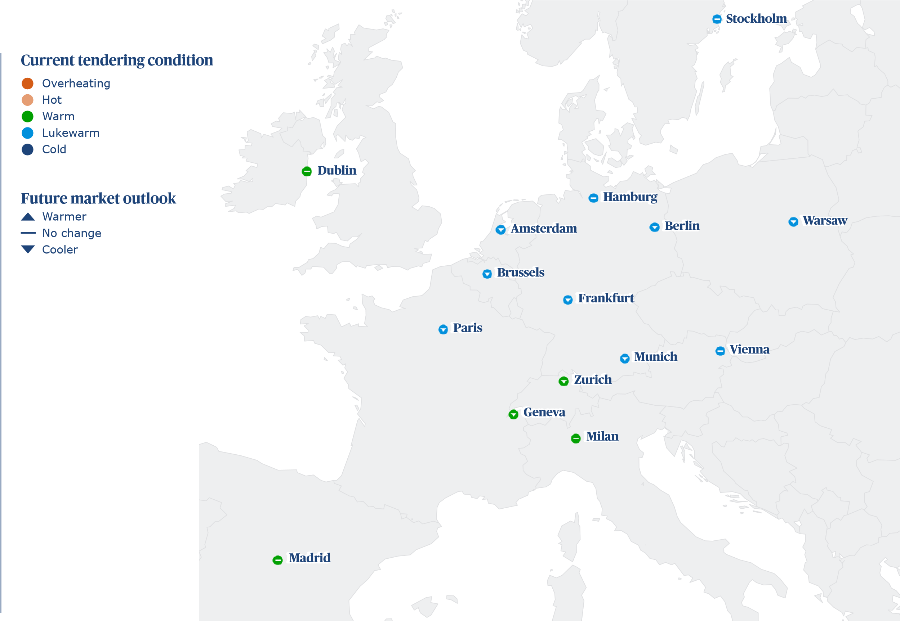
Back on stronger footing and poised for green investment
Author: Martin Londra, Regional Real Estate Lead, Europe
Europe continues to feel the pressure from war within and near its borders. However, reindustrialisation and the resilience of established hub markets, combined with cooling cost inflation, is creating opportunities.
Europe
The International Monetary Fund, in its recent World Economic Outlook, has predicted slow growth across the Euro area in 2024, which is expected to see GDP increasing at just 0.8 percent this year, marginally up from 0.4 percent in 2023.
Ireland is perhaps an outlier, predicted to break out of recession in 2024 and grow by 1.5 percent. This is owing, at least in part, to its position as an active, post-Brexit market that has been comparably less affected by the war in Ukraine than its European neighbors. Spain is also ahead of the pack with 1.9 percent forecasted growth driven by a revival in hospitality and new industrial opportunities.

making the difference

Targeting new opportunities for growth
The recently announced Net Zero Industry Act is just one measure that the EU is driving to help support investment in green manufacturing and technology. This comes in response to the US’ own raft of initiatives around the Inflation Reduction Act.
The overall trend in construction pricing is for a cooling in the rate of inflation. Sector hotspots include a continued boom in data centres, as well as advanced manufacturing facilities – particularly battery giga-factories.
Industrial sectors require both vast amounts of land and ready access to reliable power, which is driving demand outside established urban centres.
Leisure investment is also increasing, including in hotels and stadiums as Europe gears up for both the Paris Olympics and the Men’s European Football Championships in Germany this summer. This has driven investment in the French capital – one of the few markets where cost escalation is due to nudge up by 0.1 percentage points this year.
This reflects constraints in the market, including where domestic contractors have been facing larger issues around accessing credit, which in turn has made it harder to meet the cost of production.

Regional construction key challenges
Europe
0.0
20.0
40.0
80.0
100.0
60.0
Institutional instability
Political instability
Difficult contractual and legal conditions
Low workplace productivity, inefficient
Net-zero commitments
Difficulties accessing credit
The market is oversupplied, e.g. too many
Too many contractors chasing too few projects
Rising costs of construction
Increasing contractor insolvency
Excessive materials lead-in times
Government red tape, bureaucracy,
Economic instability
Lack of confidence in the market to
Skilled labour shortages
invest in new projects
delayed approvals
vacant apartments and office space
and outdated work practices
Little impact
Fair impact
Medium impact
Large impact
Major impact
(%)

How do you think supply chain will perform in the coming 12 Approximately, how has program length changed over the last 12 months? months?
Europe

20.0

46.7

33.3
Weaken
Improve
Staying
the same

13.3

40.0

46.7
Decreased
Increased
Stayed
the same
0.0 50.0 100.0 0.0 50.0 100
(%) (%

Adapting to commercial development challenges
A market contraction in more established real estate sectors, such as housing and offices, is expected to ease in anticipation of falling interest rates and corresponding improvement in access to private finance and general confidence. Local conditions are also playing their part.
Dublin has been buoyed by investment into both private and public sector housing developments on the back of an acute rental crisis in the Irish capital. This is reflected in construction demand, with a high-rise apartment in the Irish capital costing on average US$3,666.9 per m².
Purpose-built rental accommodation for specialist markets is also booming, including student accommodation around key education hubs like Munich, where prestigious universities are looking to expand ‘campus living’ with all amenities located around new student housing developments.
A similar emphasis on specification is seen outside education too, as tech companies look to encourage workers back into the office by developing high-specification work campuses and fit-outs. In Munich, this demand is pushing the price of a high-rise, high-specification office space up to US$5,608 per m².
labor pricing continues to constitute a substantial part of cost increases. A limited pool of suppliers has caused the average price of labor to reach US$84 per hour in the German industrial hub. This is the third highest across the entirety of Europe, only falling short of Zurich and Geneva, which continue to hold top tier spots in global labor cost rankings.
Europe
Costs are being exacerbated by wider geopolitical tensions, most prominently through the war in Ukraine and conflict in the Middle East, which have strained labor capacity and the movement of goods and led to greater instability across the continent.

Green investment to accelerate opportunities
Alongside financial cost, carbon is an increasing priority within development. Our own data indicates that the majority of projects in Paris, Brussels and Amsterdam are now making significant commitments towards net-zero carbon. This has been led by government regulations, but also rising consumer and employee expectations, and it is widely expected that this will only increase over time.
This also has a bearing on resources. Heading into 2025 and beyond, there will be a need for greater investment into cultivating the right pipeline of green-collared, skilled labor. This will matter even more as market confidence improves to avoid curbing investment pipelines with a capacity crunch.
A regional ranking – where are the most expensive markets?

Most expensive place to build (ft²), average cost of eleven building types in USD
Market
)
(
$

468.0

466.8

352.9

350.8

336.0

320.7

312.0

310.7

297.4

296.4

296.3

287.8

275.6

205.0

203.2
0.0
100.0
200.0
300.0
400.0
500.0
600.0
Zurich
Geneva
Munich
Dublin
Vienna
Frankfurt
Amsterdam
Hamburg
Paris
Berlin
Brussels
Stockholm
Milan
Madrid
Warsaw

Europe
Construction market metrics
Amsterdam |  | Berlin | Brussels | Dublin | Frankfurt | Geneva | Hamburg | Madrid | Milan | Munich | Paris | Stockholm | Vienna | Warsaw | Zurich
Tendering: | Lukewarm | Lukewarm | Lukewarm | Warm | Lukewarm | Warm | Lukewarm | Warm | Warm | Lukewarm | Lukewarm | Lukewarm | Lukewarm | Lukewarm | Warm
Market: | Cooler | Cooler | Cooler | Staying the  same | Cooler | Cooler | Cooler | Staying the  same | Staying the  same | Cooler | Cooler | Staying the  same | Cooler | Cooler | Cooler
Inflation 2023: (%) | 1.5 | 4.0 | 2.1 | 3.0 | 4.0 | 2.4 | 4.0 | 2.0 | 1.5 | 4.0 | 2.4 | 2.0 | 3.5 | 5.5 | 2.6
Inflation 2024: (%) | 0.5 | 1.0 | 0.5 | 3.0 | 1.0 | 2.0 | 1.0 | 3.0 | 2.0 | 1.0 | 2.5 | 1.5 | 1.0 | 5.0 | 2.0
Inflation 2025: (%) | 2.0 | 2.0 | 2.0 | 2.0 | 3.0 | 1.0 | 2.0 | 3.0 | 2.0 | 2.0 | 1.0 | 2.5 | 2.0 | 3.0 | 1.0
Contractor's margin: (%) | 4.0 | 5.0 | 5.0 | 4.0 | 5.0 | 5.5 | 5.0 | 6.0 | 5.0 | 5.0 | 6.0 | 6.0 | 5.0 | 6.0 | 5.5
Preliminaries: (%) | 13.0 | 12.0 | 13.0 | 14.0 | 12.0 | 11.0 | 12.0 | 12.0 | 12.0 | 12.0 | 12.0 | 12.5 | 13.0 | 10.0 | 12.0
Location Index (London = 100): | 75.0 | 71.3 | 71.3 | 84.4 | 77.2 | 112.3 | 74.7 | 49.3 | 66.3 | 84.9 | 71.5 | 69.2 | 80.8 | 48.9 | 112.6
CBD Offices – up to 20 floors medium (A-Grade) | 302 | 326 | 344 | 371 | 367 | 396 | 298 | 321
Education
Primary and secondary | 204 | 221 | 232 | 251 | 288 | 311 | 193 | 208
General Hospital (e.g. city teaching hospital) | 427 | 460 | 497 | 536 | 446 | 481 | 412 | 444
Hotels
3-Star travellers | 253 | 273 | 321 | 346 | 279 | 301 | 237 | 256
5-Star luxury | 447 | 482 | 423 | 456 | 511 | 551 | 430 | 464
Resort style | 333 | 359 | 362 | 391 | 358 | 386 | 317 | 342
Industrial
Advanced manufacturing facility | 331 | 357 | 251 | 271 | 316 | 341 | 266 | 287
Large warehouse distribution centre | 124 | 133 | 139 | 150 | 146 | 158 | 115 | 124
Retail
Large shopping centre including mall | 297 | 321 | 344 | 371 | 316 | 341 | 280 | 302
Neighbourhood incl supermarket | 268 | 289 | 325 | 351 | 307 | 331 | 260 | 280
Prestige car showroom | 312 | 337 | 362 | 391 | 339 | 366 | 304 | 328
Residential
Apartments high-rise | 257 | 278 | 316 | 341 | 270 | 291 | 218 | 235
Townhouses medium standard | 164 | 177 | 204 | 221 | 223 | 241 | 154 | 167
Regional construction cost performance
Europe
 | Amsterdam | Amsterdam | Dublin | Dublin | Munich | Munich | Paris | Paris
International building costs per ft² of internal area | EUR | USD | EUR | USD | EUR | USD | EUR | USD
Commercial
CBD Offices – high-rise prestige 425 458 437 471 483 521 420 453
Regional construction cost performance
Europe
 | Amsterdam |  | Amsterdam |  | Dublin |  | Dublin |  | Munich |  | Munich |  | Paris | Paris
Labour, material and plant costs | EUR |  | USD |  | EUR |  | USD |  | EUR |  | USD |  | EUR | USD
Labour costs (rates per hour)
Group 1 Tradesman e.g. plumber/electrician |  | 63 |  | 68 |  | 50 |  | 54 |  | 94 |  | 101 | 70 | 75
Group 2 Tradesman e.g. carpenter bricklayer |  | 53 |  | 57 |  | 46 |  | 50 |  | 78 |  | 84 | 58 | 63
Group 3 Tradesman e.g. carpet layer, tiler, plasterer |  | 53 |  | 57 |  | 45 |  | 49 |  | 78 |  | 84 | 51 | 55
Group 4 Green collar installation operative e.g. insulation/solar/ heat pump |  | 63 |  | 68 |  | 70 |  | 75 |  | 94 |  | 101 | 76 | 82
General labourer |  | 42 |  | 45 |  | 40 |  | 43 |  | 60 |  | 65 | 41 | 44
Site foreman |  | 74 |  | 80 |  | 60 |  | 65 |  | 84 |  | 91 | 58 | 63
Material costs
13 mm plasterboard (m²) |  | 9 |  | 9 |  | 11 |  | 12 |  | 8 |  | 9 | 6 | 7
Concrete 30 MPa (m³) (1500m³ job) |  | 164 |  | 177 |  | 125 |  | 135 |  | 240 |  | 259 | 163 | 176
Concrete block (400x200) per 1000 (>10,000 block job) |  | 1,800 |  | 1,941 |  | 800 |  | 863 |  | 1,420 |  | 1,531 | 1,538 | 1,659
Copper cable (metre) (3C + E, 2.5mm PVC) (100,000m+ job) |  | 3 |  | 3 |  | 8 |  | 9 |  | 4 |  | 4 | 4 | 4
Copper pipe 15 mm (metre) (1000+ metre job) |  | 8 |  | 8 |  | 14 |  | 15 |  | 10 |  | 11 | 9 | 10
Emulsion paint (litre) |  | 8 |  | 8 |  | 14 |  | 15 |  | 10 |  | 11 | 8 | 9
Glass pane 10mm tempered (m²) |  | 205 |  | 221 |  | 175 |  | 189 |  | 180 |  | 194 | 219 | 236
Reinforcement bar 16mm (tonne) (120 tonne job) |  | 1,206 |  | 1,301 |  | 1,000 |  | 1,079 |  | 1,650 |  | 1,780 | 1,128 | 1,217
Softwood timber for framing 100mm X 50mm (m) |  | 5 |  | 6 |  | 10 |  | 11 |  | 6 |  | 6 | 4 | 4
Standard brick per 1000 |  | 743 |  | 801 |  | 800 |  | 863 |  | 1,020 |  | 1,100 | 815 | 879
Structural steel beams (tonne) (100 tonne+ job) |  | 2,176 |  | 2,347 |  | 2,450 |  | 2,642 |  | 3,500 |  | 3,775 | 2,752 | 2,968
Plant costs (rates per day)
Hire 50t mobile crane + operator (day) |  | 1,420 |  | 1,531 |  | 1,250 |  | 1,348 |  | 1,500 |  | 1,618 | 1,250 | 1,348

Nation-building at giga-scale
Author: Mark Hamill, Regional Real Estate Lead, Middle East
Despite an unsettled political backdrop, rapid levels of investment are driving growth in the Gulf as countries look to diversify away from conventional energy. ‘Giga-projects’ are attracting global talent, while stretching supply chain capacity.
Middle East

Abu Dh
a
bi

Abu Dhabi
a
Doh

Doha
Dubai

Dubai
R
i
y
a
dh

Riyadh
Current tendering condition
Future market outlook
Overheating
Hot
Warm
Lukewarm
Cold
Warmer

No change
Cooler
With central bank interest rates beginning to fall from the highs of previous years, statebacked developments and giga-projects as part of various nation-building initiatives are continuing to drive construction activity across Gulf states.
According to the IMF’s World Economic Outlook, GDP in the Middle East region is forecast to rise by 2.8 percent in 2024 and 4.2 percent in 2025 – representing a positive trajectory, especially relative to other emerging markets. This has been buoyed by the huge number of opportunities in major mixed-use, sports, leisure and residential development.

making the difference

Regional construction key challenges
Middle East
0.0
20.0
40.0
80.0
100.0
60.0
Institutional instability
Lack of confidence in the market
Economic instability
Net-zero commitments
Political instability
Low workplace productivity, inefficient and
The market is oversupplied, e.g. too
Too many contractors chasing too few projects
Government red tape, bureaucracy,
Increasing contractor insolvency
Skilled labour shortages
Difficult contractual and legal conditions
Excessive materials lead-in times
Difficulties accessing credit
Rising costs of construction
delayed approvals
many vacant apartments and office space
outdated work practices
to invest in new projects
Little impact
Fair impact
Medium impact
Large impact
Major impact
(%)

State-backed initiatives driving growth
There has been a marked increase in construction in sports, leisure and hospitality in KSA and the United Arab Emirates.
The standout story across the region has been the accelerated growth in the Kingdom of Saudi Arabia (KSA). KSA, which by our data ranks as the world’s 19th most expensive country to build in, has seen remarkable investment as both domestic and foreign funds look to capitalise on state-backed initiatives such as NEOM and the Government’s wider 2030 vision. This has led to a growth of the major mixed-used development sector as schemes like The Line, King Salman Park and Diriyah Gate begin to take shape.
KSA is gearing up for EXPO 2030 and the 2034 FIFA World Cup by building in the necessary capacity, while also making overtures to global corporate occupiers through its Regional Headquarter Programme. This scheme encourages companies to launch offices in KSA and there are cost advantages to office investment with an average high-rise central business district office in Riyadh costing a relatively low US$2,266 per m².
Middle East
The UAE has been a hotspot for tourism in the region in recent years and its relatively low cost of construction, when compared with Western markets, still makes it an attractive place to build the hubs and amenities for international visitors.
In Dubai, residential development is buoying the local market as the city aims to support its growing population. Its attractiveness as a market is bolstered by its comparably low cost of construction with high-rise apartment buildings costing US$1,334 per m².
Data centres are an emerging sector – owing to the vast areas of land, easy access to financing and increasing demand for digital infrastructure as the Middle East expands.
How do you think supply chain will perform in the coming 12 Approximately, how has program length changed over the last months? 12 months?

25.0

50.0

25.0
Weaken
Improve
Staying
the same
Decreased
Increased
Stayed
the same

0.0

50.0

50.0
0.0 50.0 100.0 0.0 50.0 100.0
(%) (%)

Understanding the pinch points
Our survey has indicated that clients in KSA have found the shortage of skilled labour to be one of the greatest challenges for the country.
Across the Middle East, however, there are factors that are restraining its collective plans. KSA is suffering from a distinct shortage of skilled labour that is vital in delivering the country’s giga-projects.
The draw of activity in KSA contrasts with a comparable softening of market conditions in other regional capitals. As a result of this easing of demand, average labour prices in Doha have fallen slightly over the past year, with the overall rate of construction cost inflation lessening from 3.5 percent in 2023 to 2.5 percent in 2024.
Abu Dhabi has felt a similar phenomenon, seeing its own average labour costs nudge down slightly and its rate of overall construction cost inflation plateauing.
Middle East

Paving a pathway to success
Innovation in procurement is one route to addressing bottlenecks by attracting a wider pool of contractors into a market that remains dominated by larger firms.
Overall, there is a need for clients to think strategically about supply chains and investments and to integrate greater collaboration in their contracting models.
With inflation expected to come down and capacity potentially levelling out, there may be a more balancing of activity across the region. Even still, businesses should be thinking about how they can get more from less through advanced techniques and digital strategies.
A regional ranking – where are the most expensive markets?

Most expensive place to build (ft²), average cost of eleven building types in USD

241.0

194.8

174.2

171.4
Riyadh
Doha
Dubai
Abu Dhabi
(
$
)
0.0
100.0
200.0
300.0
400.0
500.0
600.0

Middle East
Construction market metrics
 | Abu Dhabi | Doha | Dubai | Riyadh
Tendering: | Warm | Cold | Hot | Hot
Market: | Warmer | Cooler | Warmer | Warmer
Inflation 2023: (%) | 4.0 | 3.5 | 5.0 | 7.0
Inflation 2024: (%) | 4.0 | 2.5 | 5.0 | 5.0
Inflation 2025: (%) | 3.0 | 3.0 | 3.0 | 5.0
Contractor's margin: (%) | 8.0 | 5.0 | 10.0 | 15.0
Preliminaries: (%) | 12.0 | 10.0 | 15.0 | 12.0
Location Index (London = 100): | 41.2 | 46.9 | 41.9 | 58.0
Group 2 Tradesman e.g. carpenter bricklayer | 22 | 6 | 38 | 10
Group 3 Tradesman e.g. carpet layer, tiler, plasterer | 22 | 6 | 38 | 10
Group 4 Green collar installation operative e.g. insulation/solar/ heat pump | 37 | 10 | 60 | 16
General labourer | 19 | 5 | 28 | 7
Site foreman | 57 | 16 | 50 | 13
Material costs
13 mm plasterboard (m2) | 15 | 4 | 26 | 7
Concrete 30 MPa (m3) (1500m3 job) | 285 | 78 | 335 | 89
Concrete block (400x200) per 1000 (>10,000 block job) | 3,000 | 817 | 6,856 | 1,827
Copper cable (metre) (3C + E, 2.5mm PVC) (100,000m+ job) | 14 | 4 | 18 | 5
Copper pipe 15 mm (metre) (1000+ metre job) | 36 | 10 | 40 | 11
Emulsion paint (litre) | 12 | 3 | 45 | 12
Glass pane 10mm tempered (m2) | 450 | 123 | 830 | 221
Reinforcement bar 16mm (tonne) (120 tonne job) | 2,500 | 681 | 3,800 | 1,013
Softwood timber for framing 100mm X 50mm (m) | 16 | 4 | 24 | 6
Standard brick per 1000 | 2,400 | 654 | 2,800 | 746
Structural steel beams (tonne) (100 tonne +job) | 8,750 | 2,383 | 10,500 | 2,799
Plant costs
Hire 50t mobile crane + operator (day) | 1,600 | 436 | 4,000 | 1,066
CBD Offices - up to 20 floors medium (A-Grade) | 530 | 144 | 651 | 173
Education
Primary and secondary | 595 | 162 | 836 | 223
General Hospital (e.g. city teaching hospital) | 1,115 | 304 | 1,022 | 272
Hotels
3 Star travellers | 558 | 152 | 790 | 211
5 Star luxury | 911 | 248 | 1,673 | 446
Resort style | 1,162 | 316 | 1,859 | 495
Industrial
Advanced manufacturing facility | 604 | 164 | 976 | 260
Large warehouse distribution centre | 353 | 96 | 558 | 149
Retail
Large shopping centre including mall | 548 | 149 | 743 | 198
Neighbourhood incl supermarket | 548 | 149 | 604 | 161
Prestige car showroom | 874 | 238 | 929 | 248
Residential
Apartments high rise | 455 | 124 | 743 | 198
Townhouses medium standard | 437 | 119 | 604 | 161
Regional construction cost performance
Middle East
   | Dubai | Dubai | Riyadh | Riyadh
  International building costs per ft² of internal area | AED | USD | SAR | USD
  Commercial
   | Dubai | Dubai | Riyadh | Riyadh
  Labour, material and plant costs | AED | USD | SAR | USD
  Labour costs
CBD Offices - high rise prestige 660 180 790 211 Group 1 Tradesman e.g. plumber/electrician 24 7 45 12

Resilience despite uncertainty
Author: Lisa Woodruff, Regional Real Estate Lead, North America
Despite elevated prices and high interest rates, the economic outlook for the United States, Canada and Mexico has remained strong. However, sticky inflation, a capacity crunch and political uncertainty may yet put this economic resilience to the test.
North America
North America as a whole is experiencing a solid economic recovery. The International Monetary Fund expects the continent to see a climb in real GDP growth from 2.5 to 2.6 percent over the coming year.
This resilience is being reflected in the real estate market, as investment flourishes in leading sectors including industrial manufacturing, life sciences, healthcare and d ata centers.

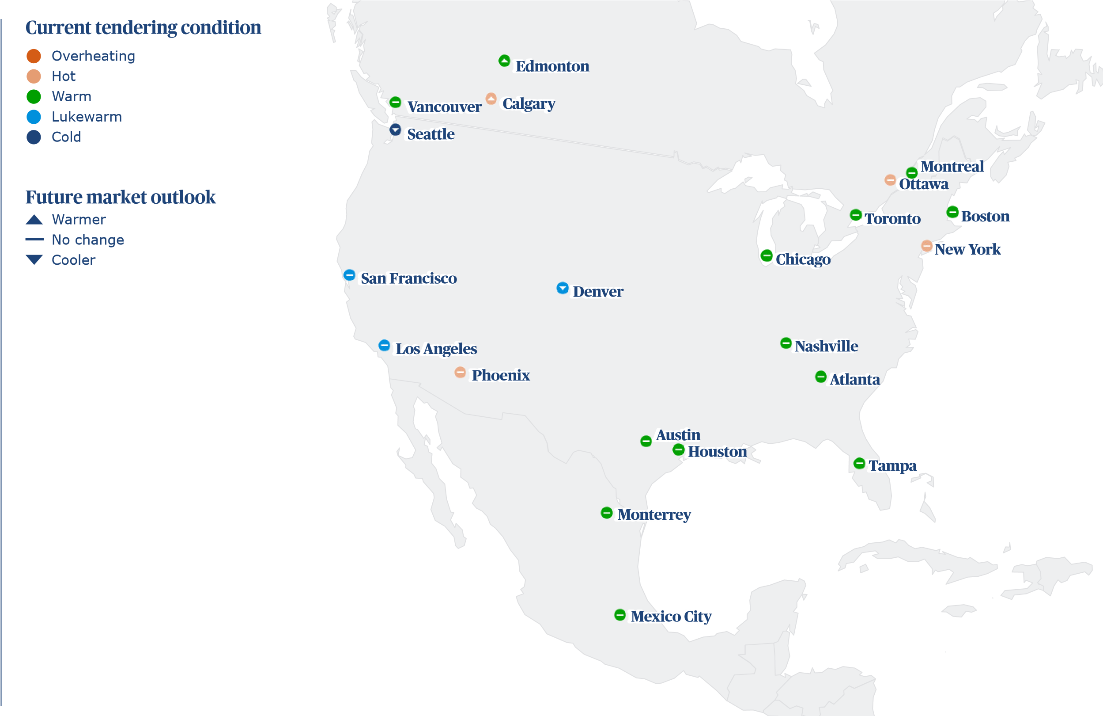

making the difference
Despite this positivity, core inflation remains Excessive materials lead-in times stubborn, giving cause for central banks to keep interest rates higher for longer. In the Rising costs of construction US, political uncertainty around November’s presidential elections is adding to the Federal Difficulties accessing credit Reserve’s sense of caution – significant rate cuts are not set to materialise for some
Lack of confidence in the market to
time. Meanwhile, in Canada, growth remains invest in new projects
sluggish with sustained, elevated interest
The market is oversupplied, e.g. too many
rates beginning to have a sharper impact on vacant apartments and office space businesses’ resilience and labour.
Difficult contractual and legal conditions
Cracks may begin to show in the real estate sector as a result, with these likely to affect
Economic instability
cost escalation forecasts.
North America
Supply chain bottlenecks have largely
settled, the US dollar has remained
strong and stable, and a recession has
likely now been avoided.
Regional construction key challenges
Skilled labour shortages
0.0
20.0
40.0
80.0
100.0
60.0
(
%
)
Little impact
Fair impact
Medium impact
Large impact
Major impact
too few projects
Political instability
Government red tape, bureaucracy, delayed approvals
Institutional instability
Increasing contractor insolvency
Net-zero commitments
Low workplace productivity, inefficient and outdated work practices
Too many contractors chasing

Growing industrial demand drives investment
Industrial is seeing huge demand as policymakers seek to onshore and nearshore advanced manufacturing capabilities and challenge China’s dominance in the production of technological components, such as batteries and semi-conductors, as well as electric vehicles.
As the need for data storage continues to boom, the number and scale of data centre projects is increasing, with hyperscalers setting out significant investment plans.
These developments are naturally clustering close to urban centres and technology hubs, where the need for data is greatest. The northeastern states of the US, the West Coast and the Midwest are seeing particularly significant growth.
Reflecting this strong demand, New York, Boston and San Francisco all saw the highest rate of construction cost escalation in the US, at 6.0 percent through 2023. Chicago, a data centre hub saw 5.0 percent cost inflation in 2023.
The trend towards large-scale data centres to meet the requirements of the increasing use of AI is benefitting markets such as Dallas in the US and Toronto in Canada, due to the availability of large amounts of affordable land nearby, outside of the metropolitan areas.
North America
In the US, funding is now flowing through federal bills including the Biden administration’s Inflation Reduction Act and CHIPS and Science Act – most prominently in the Southeast and Midwest regions. With competition high in these markets, the cost of building advanced manufacturing facilities in Atlanta and Nashville now sits at US$7,414.00 per m² and US$7,560.00 per m² respectively.
In Mexico, the rate of cost escalation is greater still. The promise of significant export markets in the US and Canada, but comparatively lower costs to build, is leading investment to be loaded into advanced manufacturing in Monterrey and Mexico City at an average cost of US$1,918.00 per m², and US$1,844.13 per m², respectively.
Large-scale projects underway in the manufacturing sector are also triggering demand more broadly, including in residential and public sectors – as well as in infrastructure – as developers work to build the homes, facilities and transport networks to attract and serve the thousands of workers.
0.0 50.0 100.0
(%)
How do you think supply chain will perform in the coming 12 Approximately, how has program length changed over the last months? 12 months?

4.8

42.9

52.4
Weaken
Improve
Staying
the same
)
(
%
0.0
50.0
100.0

9.5

38.1

52.4
Decreased
Increased
Stayed
the same

Skills shortages deepen
Our survey has indicated that clients in KSA have found the shortage of skilled labour to be one of the greatest challenges for the country.
This growing investment will place pressure on an already tight labour market, following the swathe of early retirements and career moves seen during the pandemic, pushing costs upwards across the board. The average hourly wage in North America has reached US$75, up 7.1 percent since last year, though there are significant variations across markets. San Francisco, the most expensive labour market averaging US$135 per hour compared with Mexico City at US$12.
While increased costs for skilled labour can be factored into plans from an early stage to keep projects on track, pressure on timelines and overall capacity will prove acute issues for the construction sector. A limited supply of green collar skills, for example, risks not just project delays, but limiting the progress of the industry’s carbon reduction.
North America
In Canada, another stress is being placed on capacity in the form of increased risk of insolvencies as businesses begin to feel the effects of high interest rates more acutely. While this trend is contributing to the stabilising of wage growth as vacancy rates lower, reduced capacity overall across the sector, may act to prevent cost escalation from falling sharply.
Developers will need to mitigate this capacity crunch in the immediate term – positioning themselves as an attractive client to secure the right supply chain and investing in digital tools and automation to boost efficiency. Just as important will be managing this for the long term, by bringing new talent into the industry and building the specialist skills to meet current and future needs.
A regional ranking – where are the most expensive markets?

Most expensive place to build (ft²), average cost of eleven building types in USD

531.9

510.1

452.2

437.6

430.9

425.7

400.4

382.2

378.6

364.3

362.2

337.6

322.2

284.6

282.1

276.6

265.0

247.1

246.6

191.8

186.7
New York City
San Francisco
Los Angeles
Boston
Seattle
Chicago
Atlanta
Phoenix
Nashville
Austin
Tampa
Denver
Houston
Vancouver
Ottawa
Toronto
Montreal
Edmonton
Calgary
Monterrey
Mexico City
(
$
)
0.0
100.0
200.0
300.0
400.0
500.0
600.0

North America
Construction market metrics
 | Atlanta | Austin | Boston | Calgary | Chicago | Denver | Edmonton | Houston | Los Angeles | Mexico City |  | Monterrey
Tendering: | Warm | Warm | Warm | Hot | Warm | Lukewarm | Warm | Warm | Lukewarm | Warm |  | Warm
Market: | Staying the same | Staying the same | Staying the same | Warmer | Staying the same | Cooler | Warmer | Staying the same | Staying the same | Staying the same |  | Staying the same
Inflation 2023: (%) | 5.0 | 5.5 | 6.0 | 8.0 | 5.0 | 5.0 | 8.0 | 4.5 | 4.5 | 13.0 |  | 15.5
Inflation 2024: (%) | 3.0 | 4.5 | 3.5 | 4.0 | 4.0 | 4.0 | 3.0 | 4.0 | 3.0 | 10.0 |  | 11.5
Inflation 2025: (%) | 4.0 | 4.0 | 2.5 | 3.5 | 4.0 | 3.0 | 3.5 | 3.0 | 4.5 | 12.0 |  | 16.5
Contractor's margin: (%) | 3.5 | 3.5 | 5.0 | 2.0 | 4.0 | 4.0 | 2.0 | 3.5 | 5.0 | 7.0 |  | 8.0
Preliminaries: (%) | 10.0 | 10.0 | 10.0 | 10.0 | 8.5 | 9.0 | 10.0 | 10.0 | 10.0 | 10.0 |  | 10.0
Location Index (London = 100): | 96.3 | 87.6 | 105.3 | 59.3 | 102.4 | 81.2 | 59.4 | 77.5 | 108.8 | 44.9 |  | 46.1
 | Montreal | Nashville | New York City | Ottawa | Phoenix | San Francisco | Seattle | Tampa | Toronto | Vancouver
Tendering: | Warm | Warm | Hot | Hot | Hot | Lukewarm | Cold | Warm | Warm | Warm
Market: | Staying the same | Staying the same | Staying the same | Staying the same | Staying the same | Staying the same | Cooler | Staying the same | Staying the same | Staying the same
Inflation 2023: (%) | 6.7 | 5.0 | 6.0 | 5.5 | 5.0 | 6.0 | 5.0 | 3.5 | 6.0 | 7.8
Inflation 2024: (%) | 2.0 | 4.0 | 3.5 | 4.5 | 4.0 | 2.5 | 3.0 | 3.0 | 3.5 | 3.3
Inflation 2025: (%) | 3.0 | 3.0 | 3.5 | 4.0 | 3.0 | 4.0 | 3.0 | 3.5 | 4.0 | 3.5
Contractor's margin: (%) | 4.5 | 6.0 | 5.0 | 5.5 | 6.0 | 5.0 | 4.0 | 5.0 | 4.0 | 5.0
Preliminaries: (%) | 12.0 | 10.0 | 10.0 | 13.5 | 8.0 | 10.0 | 10.0 | 11.0 | 12.0 | 12.0
Location Index (London = 100): | 63.7 | 91.1 | 127.9 | 67.8 | 91.9 | 122.7 | 103.6 | 87.1 | 66.5 | 68.5
Regional construction cost performance
North America
International building costs per ft² of internal area | Chicago  USD (ft2) |  | Chicago  USD (m2) |  | Houston  USD (ft2) |  | Houston Los Angeles Los Angeles Mexico City Mexico City  USD (m2) USD (ft2) USD (m2) MXN (ft2) USD (ft2) |  |  |  |  |  | Monterrey  MXN (ft2) |  | Monterrey  USD (ft2) |  | New York  City USD (ft2) |  | New York  City USD (m2) |  | San  Francisco USD (ft2) |  | San  Francisco USD (m2) |  | Toronto  CAD (ft2) |  | Toronto  USD (ft2) |  | Vancouver  CAD (ft2) |  | Vancouver  USD (ft2)
Commercial
CBD Offices – high-rise prestige |  | 822 |  | 8,840 |  | 525 |  | 5,654 | 743 | 8,000 | 3,988 | 241 |  | 3,903 |  | 236 |  | 991 |  | 10,660 |  | 862 |  | 9,277 |  | 506 |  | 373 |  | 523 |  | 386
CBD Offices – up to 20 floors medium (A-Grade) |  | 638 |  | 6,864 |  | 388 |  | 4,180 | 604 | 6,500 | 2,918 | 176 |  | 3,011 |  | 182 |  | 758 |  | 8,152 |  | 712 |  | 7,660 |  | 381 |  | 281 |  | 404 |  | 298
Education
Primary and secondary |  | 619 |  | 6,656 |  | 346 |  | 3,720 | 623 | 6,700 | 2,172 | 131 |  | 2,289 |  | 138 |  | 758 |  | 8,152 |  | 632 |  | 6,800 |  | 304 |  | 224 |  | 372 |  | 275
General Hospital (e.g. city teaching hospital) |  | 1,073 |  | 11,544 |  | 891 |  | 9,585 | 1,092 | 11,750 | 4,386 | 265 |  | 4,454 |  | 269 |  | 1,282 |  | 13,795 |  | 1,162 |  | 12,500 |  | 1,001 |  | 739 |  | 980 |  | 724
Hotels
3-Star travellers |  | 344 |  | 3,701 |  | 271 |  | 2,920 | 419 | 4,504 | 2,644 | 160 |  | 2,787 |  | 168 |  | 439 |  | 4,725 |  | 404 |  | 4,347 |  | 360 |  | 266 |  | 375 |  | 277
5-Star luxury |  | 684 |  | 7,361 |  | 521 |  | 5,610 | 743 | 8,000 | 4,984 | 301 |  | 5,254 |  | 317 |  | 781 |  | 8,400 |  | 770 |  | 8,285 |  | 562 |  | 415 |  | 590 |  | 436
Resort style |  | 431 |  | 4,637 |  | 340 |  | 3,655 | 457 | 4,916 | 6,084 | 367 |  | 6,412 |  | 387 |  | 484 |  | 5,204 |  | 482 |  | 5,187 |  | 461 |  | 340 |  | 483 |  | 357
Industrial
Advanced manufacturing facility |  | 714 |  | 7,678 |  | 695 |  | 7,480 | 843 | 9,070 | 2,837 | 171 |  | 2,951 |  | 178 |  | 864 |  | 9,293 |  | 861 |  | 9,261 |  | 814 |  | 601 |  | 776 |  | 573
Large warehouse distribution centre |  | 197 |  | 2,124 |  | 125 |  | 1,340 | 189 | 2,039 | 1,742 | 105 |  | 1,773 |  | 107 |  | 222 |  | 2,388 |  | 214 |  | 2,304 |  | 164 |  | 121 |  | 176 |  | 130
Retail
Large shopping centre including mall |  | 382 |  | 4,108 |  | 336 |  | 3,620 | 425 | 4,568 | 2,587 | 156 |  | 2,587 |  | 156 |  | 482 |  | 5,186 |  | 493 |  | 5,300 |  | 374 |  | 276 |  | 354 |  | 262
Neighbourhood incl supermarket |  | 217 |  | 2,340 |  | 209 |  | 2,250 | 215 | 2,317 | 2,078 | 126 |  | 2,078 |  | 126 |  | 261 |  | 2,804 |  | 260 |  | 2,793 |  | 223 |  | 164 |  | 228 |  | 168
Prestige car showroom |  | 387 |  | 4,161 |  | 372 |  | 4,000 | 413 | 4,441 | 3,278 | 198 |  | 3,278 |  | 198 |  | 468 |  | 5,040 |  | 464 |  | 4,988 |  | 442 |  | 326 |  | 466 |  | 344
Residential
Apartments high-rise |  | 387 |  | 4,160 |  | 273 |  | 2,935 | 436 | 4,688 | 2,144 | 130 |  | 2,230 |  | 135 |  | 625 |  | 6,720 |  | 613 |  | 6,594 |  | 388 |  | 286 |  | 377 |  | 278
Townhouses medium standard |  | 194 |  | 2,085 |  | 183 |  | 1,968 | 330 | 3,552 | 1,559 | 94 |  | 1,610 |  | 97 |  | 342 |  | 3,675 |  | 339 |  | 3,644 |  | 259 |  | 192 |  | 265 |  | 196
Regional construction cost performance
North America
Labour, material and plant costs | Chicago  USD (ft²) |  | Chicago  USD (m²) |  | Houston  USD (ft²) |  | Houston Los Angeles Los Angeles Mexico City Mexico City  USD (m²) USD (ft²) USD (m²) MXN (m²) USD (m²) |  |  |  |  |  | Monterrey  MXN (m²) |  | Monterrey  USD (m²) |  | New  York City USD (ft²) |  | New  York City USD (m²) |  | San  Francisco USD (ft²) |  | San  Francisco USD (m²) |  | Toronto  CAD (m²) |  | Toronto  USD (m²) |  | Vancouver  CAD (m²) |  | Vancouver  USD (m²)
Material costs
13 mm plasterboard (m²) |  | 1.0 |  | 6.0 |  | 1.0 |  | 6.0 | 1.0 | 6.0 | 171.0 | 10.0 |  | 180.0 |  | 11.0 |  | 1.0 |  | 6.0 |  | 1.0 |  | 6.0 |  | 8.0 |  | 6.0 |  | 7.0 |  | 5.0
Concrete 30 MPa (m³) (1500m³ job) |  | 20.0 |  | 210.0 |  | 19.0 |  | 200.0 | 20.0 | 210.0 | 3,517.0 | 212.0 |  | 3,838.0 |  | 232.0 |  | 20.0 |  | 211.0 |  | 20.0 |  | 210.0 |  | 284.0 |  | 210.0 |  | 298.0 |  | 220.0
Concrete block (400x200) per 1000 (>10,000 block job) |  | 195.0 |  | 2,100.0 |  | 189.0 |  | 2,033.0 | 195.0 | 2,100.0 | 13,290.0 | 803.0 |  | 13,322.0 |  | 805.0 |  | 223.0 |  | 2,400.0 |  | 220.0 |  | 2,365.0 |  | 2,957.0 |  | 2,184.0 |  | 2,776.0 |  | 2,050.0
Copper cable (metre) (3C + E,  2.5mm PVC) (100,000m+ job) |  | 1.0 |  | 7.0 |  | 1.0 |  | 7.0 | 1.0 | 7.0 | 43.0 | 3.0 |  | 125.0 |  | 8.0 |  | 1.0 |  | 8.0 |  | 1.0 |  | 8.0 |  | 9.0 |  | 7.0 |  | 9.0 |  | 7.0
Copper pipe 15 mm (metre) (1000+ metre job) |  | 1.0 |  | 10.0 |  | 1.0 |  | 9.0 | 1.0 | 10.0 | 216.0 | 13.0 |  | 227.0 |  | 14.0 |  | 1.0 |  | 12.0 |  | 1.0 |  | 12.0 |  | 12.0 |  | 9.0 |  | 14.0 |  | 10.0
Emulsion paint (litre) |  | 1.0 |  | 9.0 |  | 1.0 |  | 9.0 | 1.0 | 10.0 | 180.0 | 11.0 |  | 190.0 |  | 11.0 |  | 1.0 |  | 13.0 |  | 1.0 |  | 11.0 |  | 16.0 |  | 12.0 |  | 16.0 |  | 12.0
Glass pane 10mm tempered (m²) |  | 33.0 |  | 358.0 |  | 29.0 |  | 310.0 | 32.0 | 340.0 | 3,817.0 | 231.0 |  | 4,017.0 |  | 243.0 |  | 44.0 |  | 477.0 |  | 38.0 |  | 413.0 |  | 556.0 |  | 411.0 |  | 615.0 |  | 454.0
Reinforcement bar 16mm (tonne) (120 tonne job) |  | 177.0 |  | 1,900.0 |  | 176.0 |  | 1,890.0 | 177.0 | 1,900.0 | 27,113.0 | 1,638.0 |  | 28,539.0 |  | 1,724.0 |  | 214.0 |  | 2,300.0 |  | 217.0 |  | 2,332.0 |  | 2,880.0 |  | 2,127.0 |  | 3,076.0 |  | 2,272.0
Softwood timber for framing 100mm X 50mm (m) |  | 0.0 |  | 2.0 |  | 0.0 |  | 2.0 | 0.0 | 3.0 | 101.0 | 6.0 |  | 107.0 |  | 6.0 |  | 0.0 |  | 3.0 |  | 0.0 |  | 3.0 |  | 3.0 |  | 2.0 |  | 3.0 |  | 2.0
Standard brick per 1000 |  | 90.0 |  | 967.0 |  | 96.0 |  | 1,029.0 | 88.0 | 950.0 | 3,610.0 | 218.0 |  | 3,800.0 |  | 230.0 |  | 97.0 |  | 1,040.0 |  | 97.0 |  | 1,040.0 |  | 1,479.0 |  | 1,092.0 |  | 1,453.0 |  | 1,073.0
Structural steel beams (tonne) (100 tonne+ job) |  | 418.0 |  | 4,500.0 |  | 390.0 |  | 4,200.0 | 418.0 | 4,500.0 | 87,400.0 | 5,279.0 |  | 92,000.0 |  | 5,557.0 |  | 465.0 |  | 5,000.0 |  | 465.0 |  | 5,000.0 |  | 5,416.0 |  | 4,000.0 |  | 6,905.0 |  | 5,100.0
Regional construction cost performance
North America
Labour, material and plant costs | Chicago  USD | Houston  USD |  | Los Angeles  USD |  | Mexico City  MXN |  | Mexico City  USD |  | Monterrey  MXN |  | Monterrey  USD |  | New York City  USD |  | San Francisco  USD |  | Toronto  CAD | Toronto  USD | Vancouver  CAD |  | Vancouver  USD
Labour costs (rates per hour)
Group 1 Tradesman e.g. plumber/ electrician | 125.0 |  | 79.0 |  | 126.0 |  | 222.0 |  | 13.0 |  | 262.0 |  | 16.0 |  | 178.0 |  | 161.0 | 97.0 | 72.0 |  | 85.0 |  | 63.0
Group 2 Tradesman e.g. carpenter bricklayer | 95.0 |  | 69.0 |  | 96.0 |  | 222.0 |  | 13.0 |  | 267.0 |  | 16.0 |  | 150.0 |  | 147.0 | 86.0 | 63.0 |  | 78.0 |  | 58.0
Group 3 Tradesman e.g. carpet layer, tiler, plasterer | 95.0 |  | 56.0 |  | 96.0 |  | 220.0 |  | 13.0 |  | 267.0 |  | 16.0 |  | 150.0 |  | 145.0 | 81.0 | 60.0 |  | 78.0 |  | 58.0
Group 4 Green collar installation  operative e.g. insulation/solar/  heat pump | 102.0 |  | 75.0 |  | 126.0 |  | 360.0 |  | 22.0 |  | 381.0 |  | 23.0 |  | 175.0 |  | 157.0 | 90.0 | 66.0 |  | 90.0 |  | 67.0
General labourer | 80.0 |  | 49.0 |  | 82.0 |  | 201.0 |  | 12.0 |  | 220.0 |  | 13.0 |  | 105.0 |  | 102.0 | 77.0 | 57.0 |  | 65.0 |  | 48.0
Site foreman | 142.0 |  | 112.0 |  | 133.0 |  | 252.0 |  | 15.0 |  | 306.0 |  | 18.0 |  | 175.0 |  | 161.0 | 101.0 | 75.0 |  | 105.0 |  | 78.0
Plant costs (rates per day)
Hire 50t mobile crane + operator (day) | 4,500.0 |  | 3,115.0 |  | 4,500.0 |  | 37,800.0 |  | 2,283.0 |  | 52,700.0 |  | 3,183.0 |  | 5,245.0 |  | 4,900.0 | 2,803.0 | 2,070.0 |  | 3,435.0 |  | 2,537.0

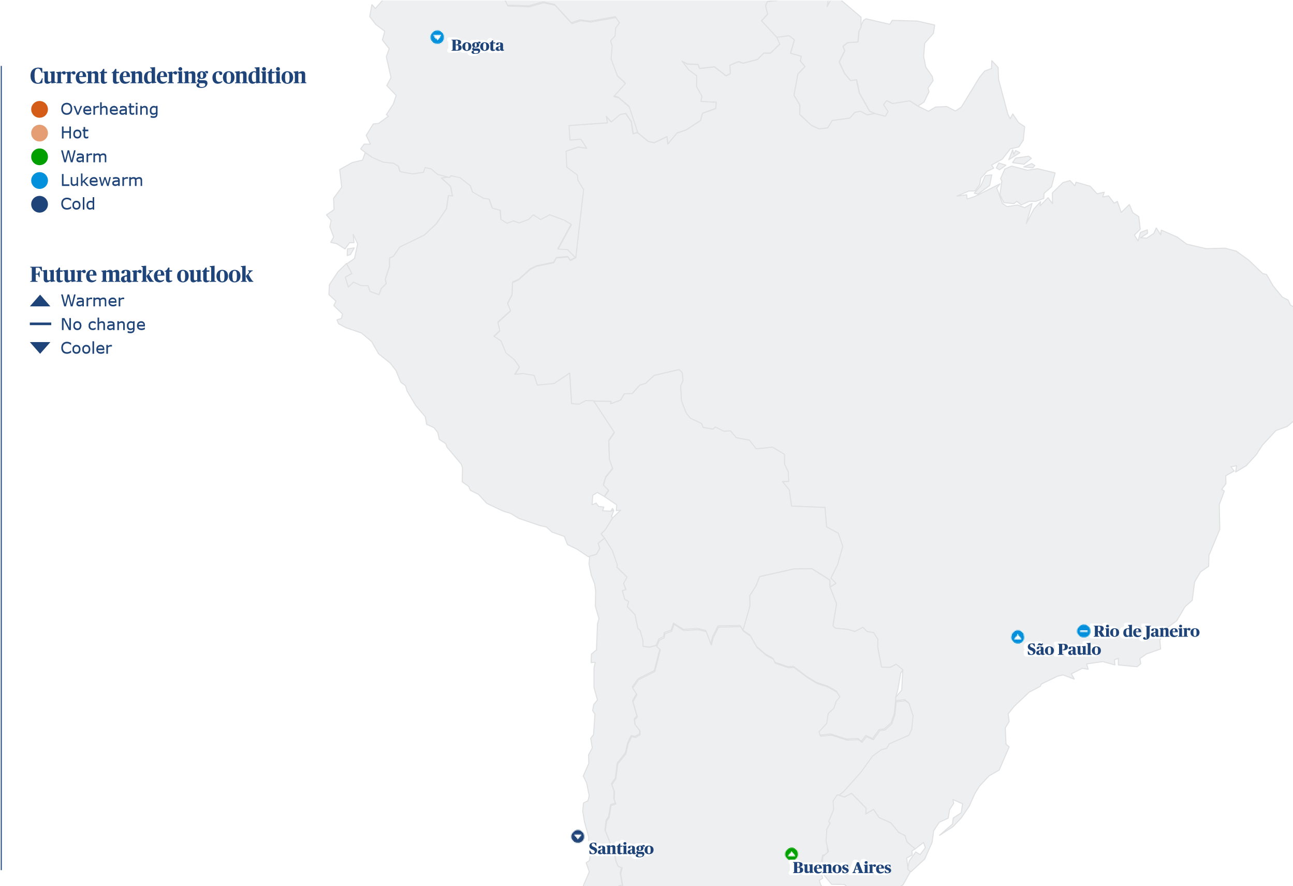
High-tech industries chart a course for growth
Author: Gareth Whisson, Regional Real Estate Lead, Latin America
With elections across the continent, political uncertainty continues. Yet as its economies continue to mature and populations grow, investment is building in high-tech sectors, healthcare and hospitality.
South America
Across 2023 and 2024, all but three South American countries will have voted in their presidential elections – bringing to a head the political turbulence with which the region is often associated. This has contributed to greater caution from some global investors and a softening in economic forecasts. Average GDP growth across the continent is expected to slow from 1.5 percent in 2023 to 1.4 percent in 2024 according to the April 2024 IMF World Economic Outlook.
Despite this, the region’s plentiful labour supply, low costs and low exposure to the economic disruption in Europe and the Middle East make it well placed to benefit from a move to nearshoring of manufacturing and investment in growth industries including industrials, life sciences and data centres.

making the difference

Regional construction key challenges
South America
0.0
20.0
40.0
80.0
100.0
60.0
Difficult contractual and legal conditions
Net-zero commitments
Low workplace productivity, inefficient
Excessive materials lead-in times
The market is oversupplied, e.g. too many
Difficulties accessing credit
Skilled labour shortages
Too many contractors chasing too few projects
Government red tape, bureaucracy,
Increasing contractor insolvency
Institutional instability
Economic instability
Lack of confidence in the market to
Rising costs of construction
Political instability
invest in new projects
delayed approvals
vacant apartments and office space
and outdated work practices
Little impact
Fair impact
Medium impact
Large impact
Major impact
(%)

High-tech, high quality, high investment
Data centre projects are expanding fast as the massive uptake of digital technology and broadband-enabled devices drive an ever-greater need for data service capacity.
The continent remains an inexpensive market for construction. The International Construction Market Survey 2024 report estimates that overall construction cost inflation will ease from 4.3 percent in 2023 to 3.9 in 2024. On the international ranking of overall cost, South American markets all fall into the lower half of the table.
Many of the multi-billion-dollar investments being seen are in high-tech labs. Post-pandemic nearshoring of life sciences manufacturing is helping to cater to growing populations and increasing healthcare demands across the continent.
Another key growth area for South America is the rise of the hospitality sector. The continent has become an increasingly popular holiday destination and premium brands are investing in new high-specification facilities in destinations across Brazil, Colombia, Chile and Mexico.
Headwinds nonetheless remain. Political, economic and institutional instability and rising costs were all significantly impacting construction work in Argentina in our survey.
Argentinian construction demand slowed following last year’s election of Javier Milei as he attempts to stabilise the economy and reduce the economic turbulence that has marred the country for many years. Inflation in the general economy peaked in early 2024 but economists are starting to forecast a precipitous decline in 2024.
These are all factors in why Buenos Aires is now the most expensive market on the continent to build in, at an average cost of US$1,927 per m². With the change in the political landscape and its coinciding impact on the economy, Argentina is beginning to get a place on investors’ watch list, particularly in the natural resources space.
How do you think supply chain will perform in the coming 12 Approximately, how has program length changed over the last months? 12 months?
South America

0.0

60.0

40.0
Weaken
Improve
Staying
the same

0.0

40.0

60.0
Decreased
Increased
Stayed
the same
0.0 50.0 100.0 0.0 50.0 100.0
(%) (%)

Understanding the pinch points
Our survey has indicated that clients in KSA have found the shortage of skilled labour to be one of the greatest challenges for the country.
Across the Middle East, however, there are factors that are restraining its collective plans. KSA is suffering from a distinct shortage of skilled labour that is vital in delivering the country’s giga-projects.
The draw of activity in KSA contrasts with a comparable softening of market conditions in other regional capitals. As a result of this easing of demand, average labour prices in Doha have fallen slightly over the past year, with the overall rate of construction cost inflation lessening from 3.5 percent in 2023 to 2.5 percent in 2024.
Abu Dhabi has felt a similar phenomenon, seeing its own average labour costs nudge down slightly and its rate of overall construction cost inflation plateauing.
South America

Paving a pathway to success
Innovation in procurement is one route to addressing bottlenecks by attracting a wider pool of contractors into a market that remains dominated by larger firms.
Overall, there is a need for clients to think strategically about supply chains and investments and to integrate greater collaboration in their contracting models.
With inflation expected to come down and capacity potentially levelling out, there may be a more balancing of activity across the region. Even still, businesses should be thinking about how they can get more from less through advanced techniques and digital strategies.
A regional ranking – where are the most expensive markets?

Most expensive place to build (ft²), average cost of eleven building types in USD
Market

179.1

162.5

158.3

157.0

144.4
Buenos Aires
Santiago
São Paulo
Rio de Janeiro
Bogota
(
$
)
0.0
100.0
200.0
300.0
400.0
500.0
600.0

South America
Construction market metrics
 | Bogota | Buenos Aires | Rio de Janeiro | Santiago | São Paulo
Tendering: | Lukewarm | Warm | Lukewarm | Cold | Lukewarm
Market: | Cooler | Warmer | Staying the same | Cooler | Warmer
Inflation 2023: (%) | 7.3 | 5.0 | 3.5 | 3.5 | 3.5
Inflation 2024: (%) | 6.5 | 3.0 | 4.0 | 3.0 | 4.0
Inflation 2025: (%) | 5.0 | 2.0 | 3.5 | 3.0 | 3.5
Contractor's margin: (%) | 8.0 | 11.0 | 8.0 | 10.0 | 8.0
Preliminaries: (%) | 10.0 | 10.0 | 10.0 | 8.0 | 10.0
Location Index (London = 100): | 34.7 | 43.1 | 37.8 | 39.1 | 38.1
Group 2 Tradesman e.g. carpenter bricklayer | 24,640 | 6 | 8,713 | 9 | 17 | 3
Group 3 Tradesman e.g. carpet layer, tiler, plasterer | 16,323 | 4 | 9,697 | 10 | 29 | 6
Group 4 Green collar installation operative e.g.  insulation/solar/heat pump | 28,235 | 7 | 10,821 | 11 | 37 | 7
General labourer | 13,578 | 4 | 5,125 | 5 | 15 | 3
Site foreman | 26,382 | 7 | 18,235 | 19 | 68 | 14
Material costs
13 mm plasterboard (m2) | 12,596 | 3 | 4,459 | 5 | 26 | 5
Concrete 30 MPa (m3) (1500m3 job) | 485,000 | 126 | 87,418 | 89 | 584 | 117
Concrete block (400x200) per 1000 (>10,000 block job) | 2,900,000 | 751 1,390,000 |  | 1,414 | 4,738 | 945
Copper cable (metre) (3C + E, 2.5mm PVC) (100,000m+ job) | 14,000 | 4 945 |  | 1 | 2 | 0
Copper pipe 15 mm (metre) (1000+ metre job) | 35,600 | 9 3,885 |  | 4 | 42 | 8
Emulsion paint (litre) | 7,714 | 2 14,852 |  | 15 | 55 | 11
Glass pane 10mm tempered (m2) | 300,800 | 78 65,450 |  | 67 | 520 | 104
Reinforcement bar 16mm (tonne) (120 tonne job) | 4,480,000 | 1,161 1,145,964 |  | 1,166 | 6,730 | 1,342
Softwood timber for framing 100mm X 50mm (m) | 16,531 | 4 3,343 |  | 3 | 9 | 2
Standard brick per 1000 | 1,200,000 | 311 166,183 |  | 169 | 880 | 176
Structural steel beams (tonne) (100 tonne +job) | 12,650,000 | 3,278 1,919,206 |  | 1,952 | 12,101 | 2,414
Plant costs
Hire 50t mobile crane + operator (day) | 3,500,000 | 907 991,516 |  | 1,009 | 5,655 | 1,128
CBD Offices - up to 20 floors medium (A-Grade) | 496,625 | 129 | 129,722 | 132 | 868 | 173
Education
Primary and secondary | 277,534 | 72 | 96,275 | 98 | 402 | 80
General Hospital (e.g. city teaching hospital) | 741,940 | 192 | 197,445 | 201 | 341 | 68
Hotels
3 Star travellers | 559,584 | 145 | 129,601 | 132 | 842 | 168
5 Star luxury | 817,067 | 212 | 227,491 | 231 | 1,474 | 294
Resort style | 913,320 | 237 | 271,545 | 276 | 1,730 | 345
Industrial
Advanced manufacturing facility | 394,241 | 102 | 127,221 | 129 | 580 | 116
Large warehouse distribution centre | 246,477 | 64 | 87,635 | 89 | 222 | 44
Retail
Large shopping centre including mall | 535,150 | 139 | 135,772 | 138 | 617 | 123
Neighbourhood incl supermarket | 457,563 | 119 | 160,458 | 163 | 361 | 72
Prestige car showroom | 527,192 | 137 | 209,830 | 213 | 739 | 147
Residential
Apartments high rise | 438,186 | 114 | 94,038 | 96 | 427 | 85
Townhouses medium standard | 389,348 | 101 | 117,258 | 119 | 238 | 48
Regional construction cost performance
South America
  International building costs per ft² of internal area | Bogota  COP | Bogota  USD | Santiago  CLP | Santiago  USD | São Paulo  BRL | São Paulo  USD
  Commercial
   | Bogota | Bogota | Santiago | Santiago | São Paulo | São Paulo
  Labour, material and plant costs | COP | USD | CLP | USD | BRL | USD
  Labour costs
CBD Offices - high rise prestige 750,456 194 193,583 197 1,213 242 Group 1 Tradesman e.g. plumber/electrician 21,267 6 7,303 7 29 6

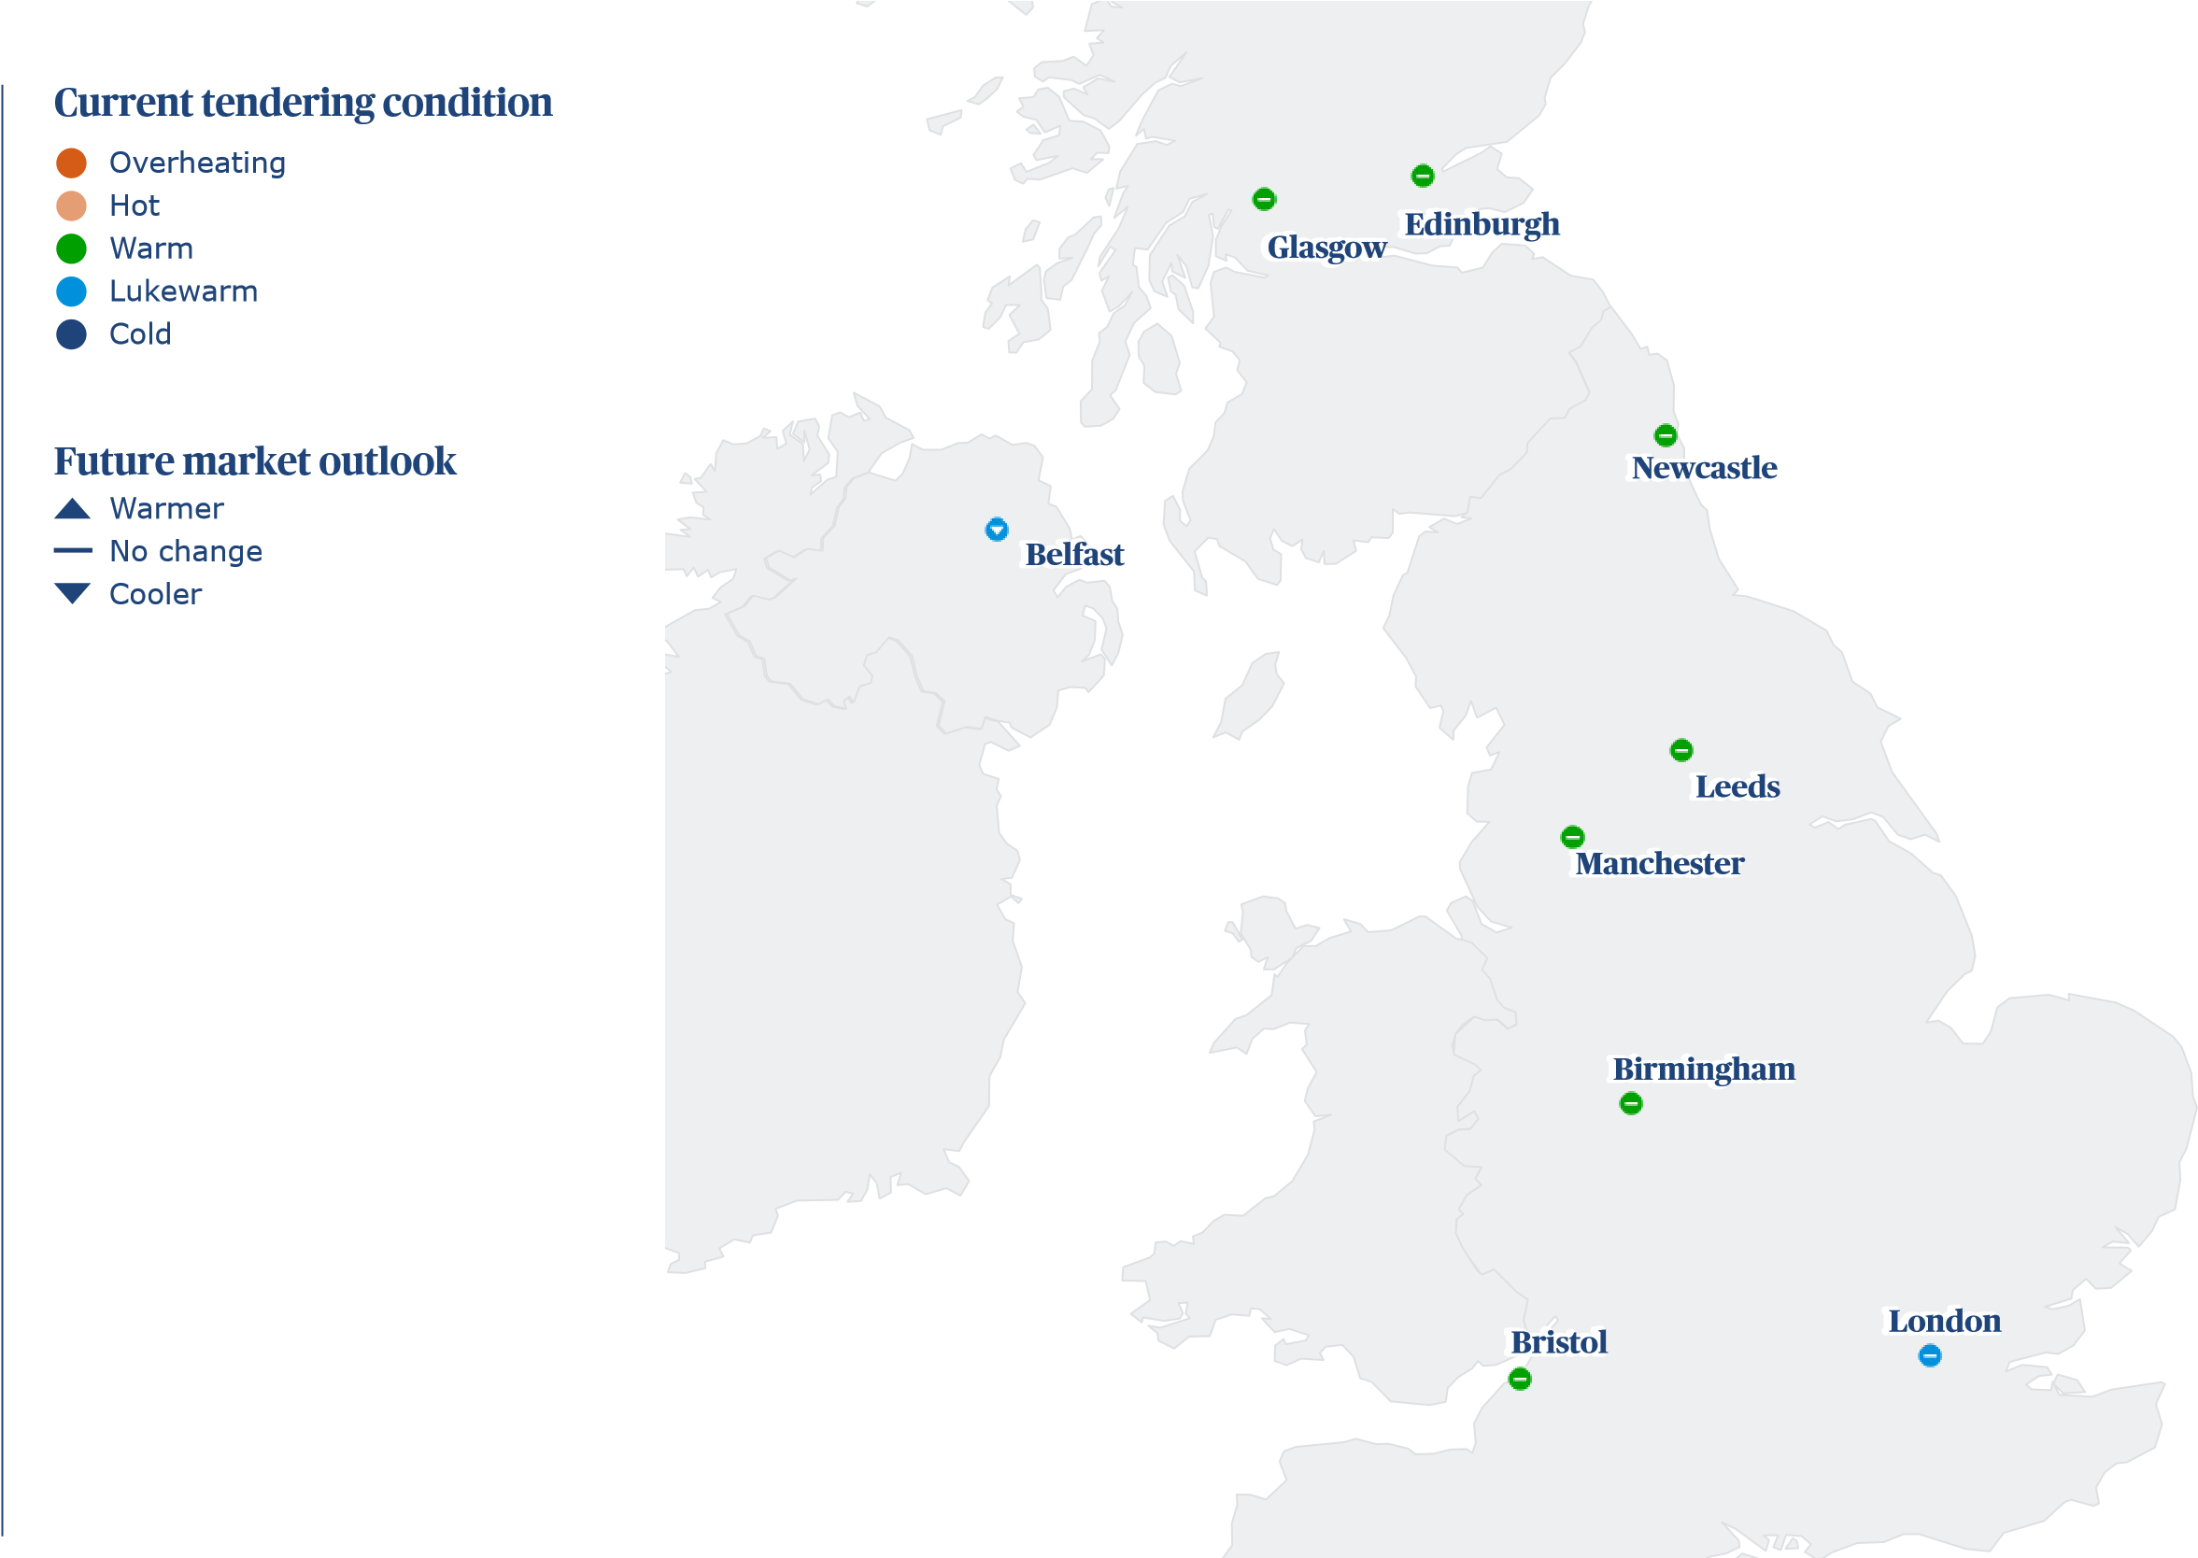
New growth catalysts revving the economic engine
Author: Chris Sargent, Regional Real Estate Lead, UK
An increasingly optimistic real estate industry is eyeing opportunities in new manufacturing sectors, alongside a recalibration of commercial space.
UK
In its April Outlook, the International Monetary Fund (IMF) predicted that the UK’s GDP growth would accelerate to 1.5 percent in 2025 from 0.5 percent in 2024. This forecast is fostering hope for construction investment across real estate development, against a backdrop of a stubborn period of low growth. In 2023, output increased by just 2.0 percent, according to the ONS, down from the 5.6 percent growth seen the year before.
With Bank of England interest rates remaining high though, there is caution among investors, meaning investment volume remains subdued – reinforced by uncertainty over which party will form the next government. However, now that the next general election has been formally called and a date set, the construction sector is looking forward to the clarity of direction which 4 July will bring. Regardless of the outcome of the vote, the hope is now that project starts will rebound by the end of 2024 as debt costs reduce.

making the difference

Regional construction key challenges
UK
Little impact
Fair impact
Medium impact
Large impact
Major impact
The market is oversupplied, e.g. too many
Too many contractors chasing too few projects
Institutional instability
Difficult contractual and legal conditions
Difficulties accessing credit
Excessive materials lead-in times
Increasing contractor insolvency
Net-zero commitments
Government red tape, bureaucracy,
Lack of confidence in the market
Low workplace productivity, inefficient and
Political instability
Economic instability
Skilled labour shortages
Rising costs of construction
outdated work practices
to invest in new projects
delayed approvals
vacant apartments and office space
0.0
20.0
40.0
80.0
100.0
60.0
(%)

Remapping the UK’s investment geography
This points to the new dynamics at play across the UK’s investment geography, in which increasing activity across a number of critical sectors is playing a role.
While constrained economic growth has helped slow inflation, overall pricing has continued to climb, deterring new development in the short term. With 3.5 percent construction cost inflation through 2023, London is now the tenth most expensive city in which to build globally. Construction costs have risen from US$3,879 last year to US$4,473 per m². In 2024, the rate of cost escalation is expected to settle to 2.0 percent.
Outside of the southeast, prices have also increased. London is followed in this year’s rankings by Manchester (30th globally, US$3,309 per m²), which has seen a 4.5 percent increase in construction costs since last year. This growth has been matched in Bristol (34th, US$3,145 per m²), Birmingham (41st, US$3,021 per m²) and Belfast (47th, US$2,939 per m²).
Large-scale industrial investment is being made across several regions. This includes growing demand for data centres to keep up with the boom in AI, as well as gigafactories to provide batteries for electric vehicles. Both facilities require an abundance of land and energy, making areas with a greater supply of available space and opportunities for quicker connection with the power grid particularly attractive to investors.
These boxes are all ticked by many northern and southwestern regions. Pockets of investment there are steadily pushing up costs. Construction for advanced manufacturing facilities in Bristol is now priced at US$2,801 per m², and in Leeds, US$2,649 per m².
How do you think supply chain will perform in the coming 12 Approximately, how has program length changed over the last months? 12 months?
UK
50.0 100.0 0.0 50.0 100.0

11.1

22.2

66.7

22.2

66.7

11.1
0.0
Weaken
Improve
Stayed
the same
Decreased
Stayed
the same
Increased
(%) (%)

The race to reduce emissions
Lack of supply is starting to drive up rents, as well as costs to build.
Tightening environmental and climate regulation is impacting commercial development as owners seek to retrofit and upgrade their portfolios and futureproof new schemes against changing occupier priorities.
High-quality, low-energy buildings with ESG credentials, amenity space and smart building technologies, reflecting the needs of a postpandemic workforce, are increasingly in demand among corporate occupiers. The cost of building a high-rise prestige office in central London has now reached US$6,035 per m².
Residential retrofitting programmes are also picking up, driven by government funding, and electric heat pump installers are especially in demand. Our figures show that this is the most sought-after green skill in construction across the majority of UK regions. Costs are high as a result. Green collar operatives, which include heat pump installers, are paid on average US$88 per hour in the capital.

The capacity crunch
These shortages are just one facet to the escalating capacity crunch within the construction industry, where real estate demand is drawing on the same pool as major infrastructure programmes in clean energy – including in nuclear, where there are plans to install 24GW of new capacity by 2050.
Some areas, notably mechanical, engineering and plumbing (MEP), are particularly badly affected. According to the Engineering Construction Industry Training Board, a fifth of engineers will have retired, or be close to it, by 2026.
UK

Enduring skills deficits
Resurgent activity has helped boost the average hourly wage up to the national average of US$50.
While some clients have started deploying strategies to counteract the supply crunch, its immediate impacts are already being felt. The average construction wage in the UK is now US$50 per hour, compared with US$45 in 2023.
A particularly large increase has been seen in Belfast, where investment has rebounded following the restoration of the devolved Northern Ireland government after a 24-month hiatus, prompted by concerns about post-Brexit trade arrangements.
Against a backdrop of rising labour costs and ongoing skills shortages, there is a critical need for investment in modern methods of construction and digitalisation – driving efficiency, streamlining processes and reducing the construction sector’s vulnerabilities to the capacity shortfall.
A regional ranking – where are the most expensive markets?

Most expensive place to build (ft²), average cost of eleven building types in USD
Market

415.7

307.5

292.3

287.8

285.2

280.8

280.2

273.6

273.2
London
Manchester
Bristol
Leeds
Edinburgh
Birmingham
Glasgow
Newcastle
Belfast
(
$
)
0.0
100.0
200.0
300.0
400.0
500.0
600.0

UK
Construction market metrics
 | Belfast | Birmingham | Bristol | Edinburgh | Glasgow | Leeds | London | Manchester | Newcastle
Tendering: | Lukewarm | Warm | Warm | Warm | Warm | Warm | Lukewarm | Warm | Warm
Market: | Cooler | Staying the same | Staying the same | Staying the same | Staying the same | Staying the same | Staying the same | Staying the same | Staying the same
Inflation 2023: (%) | 4.5 | 4.5 | 4.5 | 4.0 | 4.0 | 4.0 | 3.5 | 4.5 | 4.0
Inflation 2024: (%) | 2.0 | 3.5 | 3.5 | 3.5 | 3.5 | 3.0 | 2.0 | 3.5 | 3.5
Inflation 2025: (%) | 3.0 | 3.5 | 3.5 | 3.5 | 3.5 | 3.0 | 2.8 | 2.0 | 3.0
Contractor's margin: (%) | 3.0 | 4.0 | 6.0 | 6.0 | 6.0 | 6.0 | 4.0 | 6.0 | 4.0
Preliminaries: (%) | 13.0 | 15.0 | 14.0 | 13.0 | 13.0 | 14.0 | 15.0 | 13.0 | 14.0
Location Index (London = 100): | 65.7 | 67.5 | 70.3 | 68.6 | 67.4 | 69.2 | 100.0 | 74.0 | 65.8
CBD Offices – up to 20 floors medium (A-Grade) | 277 | 350 | 253 | 320 | 260 | 328 | 393 | 496 | 273 | 345
Education
Primary and secondary | 170 | 215 | 362 | 457 | 209 | 264 | 314 | 396 | 195 | 246
General Hospital (e.g. city teaching hospital) | 354 | 447 | 403 | 509 | 349 | 440 | 451 | 569 | 385 | 486
Hotels
3-Star travellers | 204 | 257 | 235 | 296 | 214 | 270 | 338 | 426 | 210 | 265
5-Star luxury | 322 | 407 | 334 | 421 | 321 | 405 | 598 | 754 | 351 | 443
Resort style | 280 | 353 | 292 | 369 | 288 | 364 | 390 | 493 | 342 | 431
Industrial
Advanced manufacturing facility | 202 | 254 | 188 | 237 | 195 | 246 | 203 | 256 | 199 | 251
Large warehouse distribution centre | 98 | 123 | 95 | 120 | 107 | 135 | 135 | 170 | 109 | 138
Retail
Large shopping centre including mall | 212 | 267 | 208 | 262 | 218 | 276 | 260 | 328 | 229 | 289
Neighbourhood incl supermarket | 148 | 187 | 144 | 181 | 144 | 182 | 181 | 229 | 161 | 203
Prestige car showroom | 182 | 230 | 191 | 240 | 177 | 223 | 195 | 246 | 195 | 246
Residential
Apartments high-rise | 249 | 315 | 232 | 293 | 293 | 369 | 384 | 485 | 306 | 387
Townhouses medium standard | 178 | 224 | 183 | 230 | 200 | 252 | 305 | 385 | 201 | 254
Regional construction cost performance
UK
International building costs per ft² of internal area | Birmingham  GBP | Birmingham  USD | Glasgow  GBP | Glasgow  USD | Leeds  GBP | Leeds  USD | London  GBP | London  USD | Manchester  GBP | Manchester  USD
Commercial
CBD Offices – high-rise prestige 297 375 276 349 288 364 445 561 303 382
Group 2 Tradesman e.g. carpenter bricklayer | 40 | 50 | 41 | 52 | 44 | 56 | 64 | 81 | 45 | 57
Group 3 Tradesman e.g. carpet layer, tiler, plasterer | 38 | 48 | 36 | 45 | 44 | 56 | 42 | 53 | 43 | 54
Group 4 Green collar installation operative e.g. insulation/solar/ heat pump | 47 | 59 | 45 | 57 | 47 | 59 | 70 | 88 | 52 | 66
General labourer | 28 | 35 | 27 | 34 | 30 | 38 | 28 | 35 | 30 | 37
Site foreman | 42 | 53 | 48 | 61 | 52 | 66 | 68 | 86 | 52 | 66
Material costs
13 mm plasterboard (m2) | 8 | 9 | 8 | 10 | 11 | 13 | 14 | 18 | 7 | 9
Concrete 30 MPa (m3) (1500m3 job) | 155 | 196 | 170 | 215 | 175 | 221 | 200 | 252 | 168 | 212
Concrete block (400x200) per 1000 (>10,000 block job) | 930 | 1,174 | 1,175 | 1,483 | 960 | 1,211 | 980 | 1,237 | 960 | 1,211
Copper cable (metre) (3C + E, 2.5mm PVC) (100,000m+ job) | 6 | 7 | 6 | 8 | 5 | 6 | 6 | 8 | 5 | 6
Copper pipe 15 mm (metre) (1000+ metre job) | 9 | 11 | 8 | 10 | 9 | 11 | 9 | 11 | 8 | 11
Emulsion paint (litre) | 6 | 8 | 6 | 8 | 8 | 9 | 6 | 8 | 8 | 10
Glass pane 10mm tempered (m2) | 133 | 168 | 160 | 202 | 155 | 196 | 182 | 230 | 176 | 222
Reinforcement bar 16mm (tonne) (120 tonne job) | 1,700 | 2,145 | 1,450 | 1,830 | 1,500 | 1,893 | 1,800 | 2,271 | 1,760 | 2,221
Softwood timber for framing 100mm X 50mm (m) | 8 | 10 | 8 | 10 | 8 | 10 | 9 | 11 | 9 | 11
Standard brick per 1000 | 630 | 795 | 650 | 820 | 675 | 852 | 800 | 1,009 | 840 | 1,060
Structural steel beams (tonne) (100 tonne +job) | 3,400 | 4,290 | 2,600 | 3,281 | 2,750 | 3,470 | 3,588 | 4,528 | 4,235 | 5,344
Plant costs
Hire 50t mobile crane + operator (day) | 1,100 | 1,388 | 1,450 | 1,830 | 1,550 | 1,956 | 3,000 | 3,785 | 1,523 | 1,921
Regional construction cost performance
UK
Labour, material and plant costs | Birmingham  GBP | Birmingham  USD | Glasgow  GBP | Glasgow  USD | Leeds  GBP | Leeds  USD | London  GBP | London  USD | Manchester  GBP | Manchester  USD
Labour costs
Group 1 Tradesman e.g. plumber/electrician 46 58 42 53 44 56 55 69 45 57

05 | Methodology

Comparing construction costs
Comparing construction costs internationally is not just about providing indicative costs across global markets, but also gaining understanding best practice in different countries – which can spark innovation in design and delivery.
Convert to a single currency – USD for comparison.
Most of the international comparisons drawn within this report are linked to currency exchange. This is the most common and useful means of comparison for a multinational organization paying for projects in its home currency.
Market volatility is a mainstay in the current economic climate, and this uncertainty, coupled with contractionary monetary policy, continues to impact exchange rates and the affordability of many countries’ imports and exports. Our exchange rates compare March 2024 values against March 2023, and so exclusively capture changes within that window of time. Between March 2023 and March 2024, 69.7 percent of currencies have depreciated against the US dollar, while 30.3 percent appreciated.
Higher US interest rates aimed at curbing inflation, and better than expected economic growth attracted investors seeking better returns and driving up the US dollar. This strength weakened other currencies as the US became a more attractive investment. Increased geopolitical tensions have also boosted the value of the US dollar.
While this is not picked up directly in the cost data we analysed in our 2024 report, it plays a prominent role in comparing international constriction costs. As such, a watchful eye is needed to monitor and evaluate currency trends, which can heavily impact project and programme costs.
Figure 14:

Exchange rates movement, 2023 vs. 2024
(
%
)

-74.9

6.9
-6

-19.6

-14.1

-12.1

6.6
-

-
5.7

5.6
-

5.4
-

-4.9

-4.9

-4.5

-3.3

-3.2

-2.8

-2.7

-2.6

-1.4

-1.4

-0.8

-0.2

-0.1

-0.0

0.2

0.3

0.4

1.3

1.5

2.0

2.0

8.2

9.1

20.2
-90.0
-80.0
-70.0
-60.0
-50.0
-40.0
-30.0
-20.0
-10.0
0.0
10.0
20.0
30.0
Argentine Peso
Nigerian Naira
Chilean Peso
Rwandan Franc
Japanese Yen
Malaysian Ringgit
Indonesian Rupiah
South African Rand
Vietnamese Dong
Botswanan Pula
Chinese Yuan
New Zealand Dollar
Philippine Peso
South Korean Won
Ugandan Shilling
Swedish Krona
Australian Dollar
Indian Rupee
Singapore Dollar
Euro
Saudi Riyal
Canadian Dollar
United Arab Emirates Dirham
Kenyan Shilling
Macanese Pataca
Qatari Riyal
Brazilian Real
Swiss Franc
Great British Pound
Hong Kong Dollar
Polish Złoty
Mexican Peso
Colombian Peso
Country
The average cost in USD for the following different building types are assessed to calculate the ranking of how expensive each market is to build in.
- CBD Offices - high-rise prestige
- CBD Offices - up to 20 floors medium
(A-Grade)
- 3 Star travellers
- 5 Star luxury
- Resort style
- Large warehouse distribution centre
- Large shopping centre including mall
- Neighbourhood including supermarket
- Prestige car showroom
- Apartments high rise
- Townhouses medium standardAdvantages
- Easy to understand and visualise.
- Gives the cost of typical building in each country.

Disadvantages
- A change in the exchange rate makes a significant difference: if a particular currency is strong compared to the base currency, the cost of construction looks expensive.
- Is not a reliable indicator of relative costs and efficiency of construction between countries.

Location index
The location index provided in this document offers a common base to compare costs of construction across different markets. London equals 100 as the initial base or reference point, with the deviation from 100 driven by our average cost in USD of several different building types of construction.

Terms and references

Building costs per m²
The average cost per square meter of a building measured to the outer perimeter of external walls or other external construction features, sheltered areas and external floor areas. In this survey, building costs per m², sometimes referred to as direct costs (as opposed to indirect costs), are for construction of the building, including preliminaries (or general conditions) costs and substructure, columns, upper floors, staircases, roof, external walls, external doors, internal walls, internal doors, wall finishes, floor finishes, ceiling finishes, fitments, plumbing, HVAC, fire protection, electrical and communication systems and transportation systems.
It is assumed that building costs are based on the typical building standards and building methods for the region.
This survey’s building costs per m² information comes from programmes underway at the beginning of 2024, relevant for Q1 2024, and excludes applicable taxes. All exchange rates are from March 2024.
Our international building costs per m² comparison has been calculated using the average values of the typical costs of all asset classes within our survey – excluding new data entries. Cost per m² information, collated from our survey, has formed the baseline of our in-house view of international building cost comparisons and rankings. Expert opinions of experienced colleagues and sector specialists, informed by projects and programmes delivered in each location, and external data have been used to support decision making.
Costs, comparisons and location factors are only applicable for generalised building works as a high-level indication of preliminary costs. They are only suitable as an initial assessment of approximate build costs and quoted figures are to be treated with at least a +/-10.0 percent range of accuracy.
Actual costs are dependent on building design, inclusions, exclusions, and site conditions. Cost comparisons between countries are subject to different interpretations, building methods, and standards for costing, measurement, and construction. Costs may vary substantially between regions within countries.

Exclusions from building costs per m²
External works, landscaping, professional fees, demolition, loose furniture, fittings and equipment, developer’s internal costs and finance, local authority fees and headworks charges, land, legal, finance and holding costs, GST or sales taxes, site investigation and test bores, removal of significant obstructions in the ground, abnormal footings. Allowance for underground or onsite car parking is also excluded from the building cost unless stated otherwise.

Labour costs
Labour costs are the all-inclusive cost to the employer, which includes the basic hourly wage, allowances, taxes, annual leave cost, and where paid by the employer, workers’ compensation and health insurance, pensions, and travel costs and fares. It excludes overheads, margins, overtime and bonuses.

Inflation forecasts
This report contains forward looking construction cost inflation data that are subject to risk factors associated with global and local market changes. It is to be noted, that at the time of this report’s publication, the expectations reflected in these indices are reasonable. However, given the current volatile market conditions and rapid pace at which market conditions have and are continuing to change, these forecasts may be affected and may no longer be valid.
Therefore, the inflation forecasts included in this report should be used only as a guide. Turner & Townsend recommends seeking the advice of a local Turner & Townsend representative or contact prior to the use of these allowances, to ensure they are valid and remain current.

06 | Contact
Pablo Cristi Worm  Associate Economist, UK  pablo.cristiworm@turntown.co.uk | Kris Hudson  Associate Director, North America  kristoffer.hudson@turntown.com | Tiffany Emmett  Associate Director,  Australia and New Zealand  tiffany.emmett@turntown.com | Nitesh Patel  Lead Economist, UK  nitesh.patel@turntown.co.uk





Our expert team of construction economists would love to answer any

questions you have about the research

About Turner & Townsend
Turner & Townsend is a global professional services company with over 10,700 people in 48 countries.
Collaborating with our clients across real estate, infrastructure and natural resources sectors, we specialise
in major programmes, programme management, cost and commercial management, net zero and digital
solutions.
We are majority-owned by CBRE Group, Inc., the world’s largest commercial real estate services and
investment firm, with our partners holding a significant minority interest. Turner & Townsend and CBRE work
together to provide clients with the premier programme, project and cost management offering in markets
around the world.
We are passionate about making the difference, transforming performance for a green, inclusive and
productive world.
m
www.turnerandtownsend.co
© Turner & Townsend Limited. All rights reserved June 2024. This content is for general information purposes
only and does not purport to constitute professional advice. We do not make any representation or give any
warranty and shall not be liable for any losses or damages whatsoever, arising from reliance on information
contained in this document. It must not be made available or copied or otherwise quoted or referred to in
whole or in part in any way, including orally, to any other party without our express written permission and
we accept no liability of whatsoever nature for any use by any other party.

